Team Project Report

Bio-Inspired Optimization of the Multiple Traveling Salesman Problem

Submitted to

The 2018 RET Site
For
“Engineering Design Challenges and Research Experiences for
Secondary and Community College Teachers”

Sponsored by
The National Science Foundation
Grant ID No.: EEC-1710826

College of Engineering and Applied Science
University of Cincinnati, Cincinnati, Ohio

Prepared By
Participant # 1: Beth Francis, Gifted, grades 3-8, Felicity Franklin Elementary Middle School, Felicity, Ohio
Participant # 2: Kelly Lindsey, Math, grades 9-12, Boone County High School, Florence, Kentucky

Approved by

________________________________________ ______________________________________
Dr. Manish Kumar Dr. Jeffrey Kastner
Department of Engineering Education
College of Engineering and Applied Science
University of Cincinnati

Reporting Period: June 11 – July 27, 2018

Abstract
This research applies the Traveling Salesman Problem to optimization difficulties specifically related to the use of drones for deliveries and aerial surveys. This research project focuses on finding an efficient algorithm that will aid in the design of delivery routes that are shorter, easier to follow, and cover the most territory. One part in the research is to fin optimal parameters for a genetic algorithm to reduce the travel distance in the traveling salesman problem while also reducing the computational time needed to generate a more optimal path. A genetic algorithm loosely applies the idea of biological natural selection to computer programs that enable the development of efficient travel through Artificial Intelligence (AI) systems used in unmanned drones. MATLAB software was used to test sets of parameters for both a single ‘salesman’ problem and for a multiple ‘salesmen’ problem operating out of a single depot. While this algorithm is not expected to produce a final solution, it hopes to move the project forward with a more optimal solution than previously available. This solution can then be further modified to be used in drone AI.
Key Words
Traveling salesman, genetic algorithm, circuit, optimization, nearest neighbor, 2-Opt
Main Body
1. INTRODUCTION
This research project focuses on finding an efficient algorithm that will aid in the design of paths that are shorter, easier to follow, and cover the most territory while optimizing energy use. One part of the research is to test parameters in a genetic algorithm to see if they will reduce the travel distance in the Traveling Salesman Problem and to test the use of clustering with depots in the Multiple Traveling Salesman Problem. Optimization is the process of finding the best path that costs the least in terms of time and/or distance. Some processes like the 2-Opt Algorithm find a solution very quickly but it is often not of the shortest distance. Other processes like Genetic Algorithms find a near minimum distance but take a lot of time. It is hopeful that this research will find a modified Genetic Algorithm that takes much less time for a minimal increase in distance.
There are many applications for optimization in the world of delivery routes and Artificial Intelligence. Drones are being used for aerial surveys and are in development for delivery but have a limited battery life. This research is trying to create an algorithm that will produce the most efficient travel path for the power available.
2. LITERATURE REVIEW
According to Applegate et al. (2007), the Traveling Salesman Problem (TSP) is “one of the most intensely investigated problems in computational mathematics.” The TSP tries to find the optimal path for visiting all the given cities. The salesman must visit each city only once and return to the starting city. Optimization is the process of adjusting the inputs to find the minimum or maximum output (Haupt, R. and Haupt, E. 1998). For the TSP, optimization means to find the shortest distance or the least cost. The TSP has been useful in many applications such as “logistics, genetics, manufacturing, telecommunications, and neuroscience” (Applegate et al., 2007). The major limiting factor to solving the TSP is the rapid increase of time as the number of cities increases (Sathyan et al., 2015). This has led researchers to develop various algorithms to address this limiting factor. These algorithms can be broken up into two categories: exact algorithms and heuristic algorithms. Exact algorithms will compute all permutations (n!) and heuristic algorithms reduce complexity by finding an approximate optimal solution (Alemayehu and Kim, 2017).
The Nearest Neighbor heuristic TSP algorithm (NN) begins with a random chosen city and then adds the distance to the nearest city not visited. This process continues until all cities are visited and the traveling salesman returns to the original city. This algorithm yields the sequence of cities visited. NN provides the nearly optimal route and short amount of time (Alemayehu and Kim, 2017). Many studies have focused on reducing the “data delivery latency” due to the optimal tour depending on the layout of the cities (Alemayehu and Kim, 2017).
Since the NN’s effectiveness depends on the layout of the cities, the 2-opt algorithm provides a way to swap paths when they cross to produce a more optimal path. The following figures demonstrate how the 2-opt works. “Figure 1 shows an example of a potential tour that visits all nodes exactly once and forms a cycle” (Kuang, 2012). As one can tell, Figure 1a is not an optimal tour because paths are crossing. In figure 1b, the solution swaps (a,c) to (a,b) and (b,d) to (c,d) which is a better path than Figure 1a. The solution on the right in Figure 1c swapped (a,c) to (a,d) and (b,d) to (b,c) which created a disconnected tour. The 2-opt continues until no swaps can be made to improve the path (Kuang, 2012).
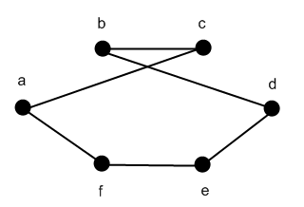
Figure 1a
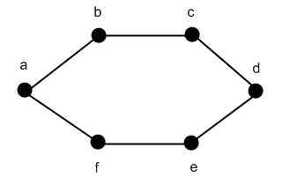  Figure 1b | 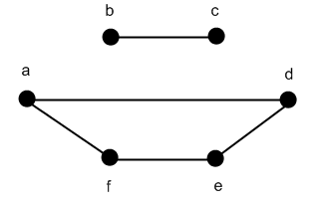  Figure 1c
Figure 1: Sample tour with six locations
Kramer (2017) describes genetic algorithms (GA) as “the translation of the biological concept of evolution into algorithmic recipes.” According to Haupt and Haupt (1998), the genetic algorithm (GA) “is a subset of evolutionary algorithms that model biological processes to optimize highly complex cost functions. [It] allows a population composed of many individuals to evolve under specified selection rules to a state that maximizes the “fitness” (ie., minimizes the cost function).” There are several advantages to using the GA.
“Some of the advantages of a GA include that it
- Deals with a large number of parameters
- Is well suited for parallel computers
- Provides a list of optimum parameters, not just a single solution
- Works with numerically generated data, experimental data or analytical functions
- Simultaneously searches from a wide sampling of the cost surface
- Optimizes parameters with extremely complex cost surfaces; they can jump out of a local minimum” (Haupt & Haupt, 1998).

Figure 2 demonstrates the path of the GA. As with all optimization algorithms, the GA starts with defining the parameters, cost function and cost.
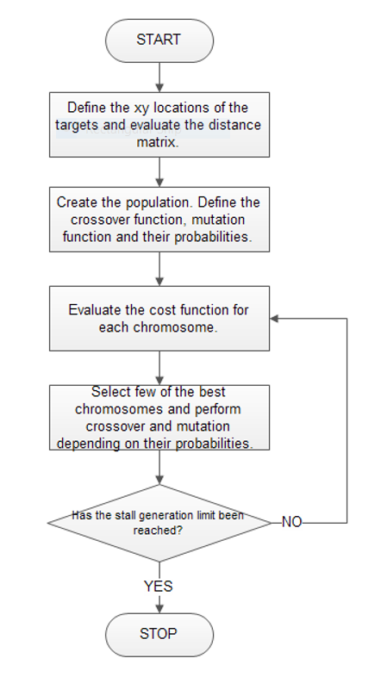
Figure 2: Flowchart: Genetic Algorithm (Sathyan 2015)

The multiple traveling salesman problem (MTSP) adds another level of complexity to the TSP by adding multiple traveling salesmen and depots. Multiple depots and closed paths are big issues for the MTSP. According to Hou and Liu (2012) “the MTSP seems to be more appropriate than the TSP for practical applications and can be used to simulate many everyday applications such as transportation logistics, job planning, vehicle scheduling, and so on.” There have been several applications of the GA to solve the MTSP. One solution utilized a hybrid GA based on tabu search. Another solution studied chromosome and related genetic operators to solve the MTSP. A third solution applied the ant system to the MTSP (Hou & Liu, 2012).
3. GOALS AND OBJECTIVES
One goal of the research was to develop a better solution to the TSP by introducing parameters into the GA that find a shorter path. Another goal was to develop a GA that used clustering to optimize the MTSP. To reach these goals, there were the following objectives: (1) learn and understand code written in MATLAB, (2) amend the GA by introducing additional parameters, (3) test the amended GA against the pre-written NN and 2-Opt programs, (4) use clustering to create a GA for the MTSP, (5) test the GA for the MTSP.
4. RESEARCH STUDY DETAILS
At the beginning of the project, both RET teachers became familiar with MATLAB software. They spent 5-7 days learning the coding processes of the software and how to analyze code to gain a basic understand of what was happening. In the third week, the team began to look at several algorithms to see how they found paths for the TSP.
After thoroughly understanding the concepts of the Traveling Salesman Problem, the RET teachers tested for solutions using the Nearest Neighbor (NN), Convex Hull CH), 2-Opt, GA, and my_GA (a modified Genetic Algorithm) algorithms.
4.1 The Traveling Salesman Problem

Let 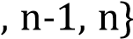 be the set of indices defining the targets and be the distance between the 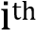 and 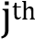 targets. The problem is assumed to be symmetric so that:

(1)
It is assumed that the triangle inequality holds true, i.e.

(2)
The TSP can be formulated as an integer linear problem. Let be a vector that represents the tour.

(3) (4)
For to be a tour satisfying the conditions of TSP, should be of length 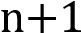 with each value in being unique.

(5)

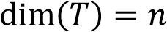 (6)

The total distance traversed by the UAV following tour is given by,

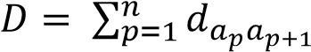 (7)
and 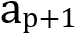are indices of the targets. The total distance traversed by the UAV, given by , is
the cost function that needs to be minimized. Thus, as the objective is to

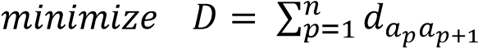 (8)
(Sathyan et al. 2015)

The mathematical explanation of the TSP above shows that the goal is to minimize the total distance required to visit each city (target) and return to the start.

4.2 Nearest Neighbor

The Nearest Neighbor (NN) heuristic provides a reasonable upper bound for the shortest distance of the TSP (Alemayehu and Kim, 2017). It involves traveling to the nearest unvisited city until all cities have been visited and then returning to the start city. The heuristic is relatively easy to use to compute a total distance for a small sample of cities and yields a distance that averages 25% larger than the shortest distance (Johnson and McGeoch, 1997). Figure 4 shows one such Nearest Neighbor path for 50 cities in the United States. There are several places where edges cross each other, which indicates a distance that is greater than the shortest one.

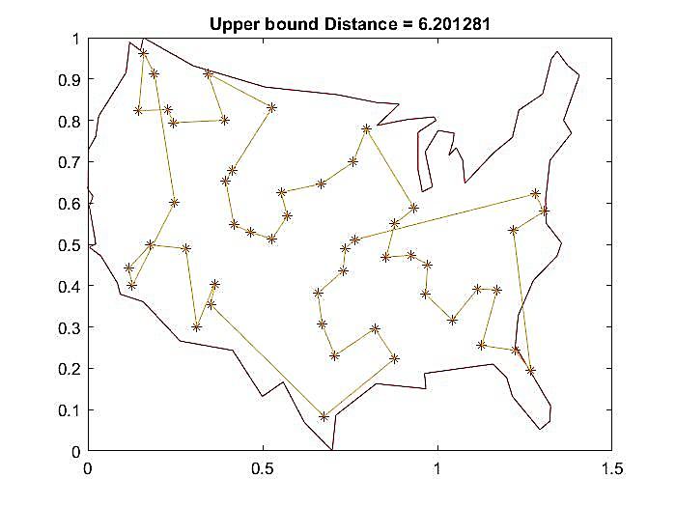
Figure 3. Nearest Neighbor Graph

4.3 Convex Hull

As the meaning of the word “convex” implies, the Convex Hull algorithm is used to define a
convex polygon whose path encloses or includes all the cities in set. All the cities lie on the boundary of
the polygon or inside the interior of the polygon. The vertices of the polygon are cities in the set. This
method of finding a path is usually not a circuit through all the cities but ensures that a reasonable lower
limit for the optimal path is found (Applegate et al. 2007). Figure 5 shows a Convex Hull for the same 50 cities previously defined. Using the distance of the Convex Hull and the NN, it is evident that any optimal path for the given 50 cities must lie between (inclusively) 3.405281 and 6.201281. These numbers formed the bounds for further testing of other algorithms.
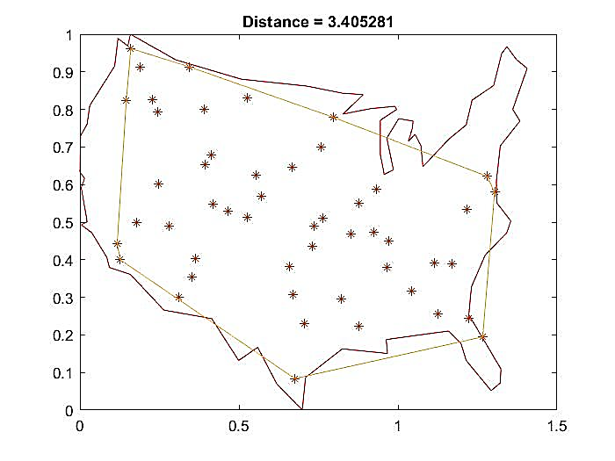
Figure 4. Convex Hull Graph

4.4 2-Opt Method

The 2-Opt method is a simplified form of the Lin-Kernighan algorithm, also known as k-opt, developed by Shen Lin and Brian Kernighan (1973). Their article “An Effective Heuristic Algorithm for the Traveling-Salesman Problem” lays out a tour improvement method in which sets of longer edges are replaced by sets of shorter edges, thereby reducing the total distance of the tour. Figure 6 shows the flowchart of tasks for the 2-Opt method.

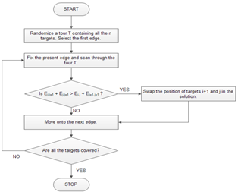

Figure 5. Flowchart: 2-Opt

The MATLAB coding in Table 1 was used to find shorter distances for the same 50 cities.

Table 1. MATLAB code for 2-Opt algorithm by Anoop Sathyan

tic
clc;
clear all;
close all;
coordinates = xlsread('coordinates.xlsx');
distance = pdist(coordinates);
dmat = squareform(distance);
n = 50;
num_iter = 100;
opt_rte = [1:1:n];
newopt = opt_rte;
newopt(n+1) = opt_rte(1);
plot(coordinates(:,1),coordinates(:,2),'r.');
pfig = figure('Name','Current Best Solution','Numbertitle','off');

for iter = 1:num_iter,
for i = 1:n-2,
for j = i+2:n,
d1 = dmat(newopt(i),newopt(i+1)) + dmat(newopt(j),newopt(j+1));
d2 = dmat(newopt(i),newopt(j)) + dmat(newopt(i+1),newopt(j+1));
if d1 > d2
[newopt(j),newopt(i+1)] = deal(newopt(i+1),newopt(j));
else
end
if i == 1,
newopt(n+1) = newopt(1);
elseif (i == n)||(j == n)
newopt(1) = newopt(n+1);
end
end
end
end
optresult = newopt(1:n);
xy_opt = coordinates(optresult,:);
xy_opt(n+1,:) = coordinates(optresult(1),:);
distance = 0;
for ii = 1:n-1,
distance = distance + dmat(optresult(ii),optresult(ii+1));
end
total_distance = distance + dmat(optresult(1),optresult(n));
load('usborder.mat','x','y','xx','yy');
plot(x,y,'Color','red');
hold on;

figure(pfig)
plot(xy_opt(:,1),xy_opt(:,2),'r.-')
title(sprintf('Distance = %f',total_distance))
disp('Output_Benchmark_Anoop_2-Opt')
disp(['The shortest path is: ',num2str(total_distance)])
toc

The 2-Opt algorithm begins with a NN tour similar to Figure 4. Then it swaps any edges that cross each other, producing a shorter total distance. Figure 7 shows a possible 2-Opt tour with a total distance of 5.834875 which is in the expected range between the Nearest Neighbor (6.201281) and the ConvexHull (3.405281).
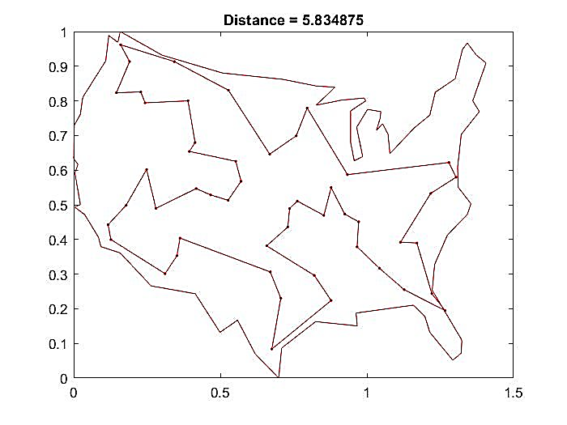
Figure 6. 2-Opt Graph

4.5 Genetic Algorithms

4.5.1 MATLAB Genetic Algorithm

The first Genetic Algorithm used in the research was from MATLAB. Given the same 50 cities used for the NN, Convex Hull, and 2-Opt, the code in Table 2 was run as a benchmark with population size 60 for 10,000 iterations.

Table 2. MATLAB Benchmark TSP Genetic Algorithm

% Benchmark TSP GA %

tic
clc;
clear all;
close all;

coordinates = xlsread('coordinates.xlsx');
distance = pdist(coordinates);
distance = squareform(distance);
popsize = 60;
iter = 1e4;
show_prog = 1;
show_res = 1;

load('usborder.mat','x','y','xx','yy');
plot(x,y,'Color','red');
hold on;

[opt_rte,min_dist] = tsp_ga(coordinates, distance, popsize, iter, show_prog, show_res);

disp('Output_Benchmark_TSP_GA')
disp(['The optimal tour length is: ',num2str(min_dist)])
toc
Figure 8 shows a possible solution using the MATLAB GA with a total distance of 5.8373. This distance is very close to the 2-Opt solution.
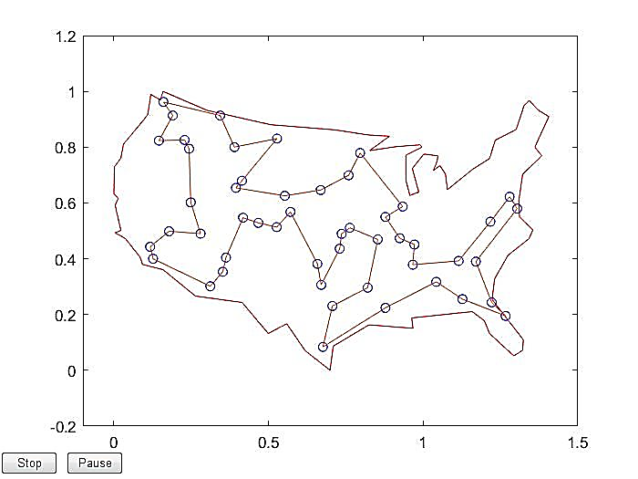
Figure 7. MATLAB GA Graph

4.5.2 The Modified Genetic Algorithm my_GA

The next step in the research was to test a new Genetic Algorithm (Loopforbest_YourGA) for a range of values for i (generations), j (population size), s (crossover fraction), and k (iterations). The values tested were i = 550:600, j = 100:200, s = 0.1:1, and k = 1.. The results of this long run were stored in a spreadsheet that recorded k, i, j, s, and distance. The program used the same selection of 50 cities as in previous algorithms.

When finished the algorithm generated 15,810 lines of record. The five shortest distances with their parameters were extracted and re-run in the Loopforbest_YourGA program for 10 iterations to see if any one of them had shorter distances on average than the other four. The parameters that had the shortest distances moved on to the next stage of testing.

4.5.3 Comparison Testing of 2-Opt, MATLAB GA, and my_GA

Both RET participants extracted a set of parameters that produced the best distance in the my_GA testing. Those two sets were tested in a comparison program that ran all 3 algorithms with the same parameters and the same randomized cities. This allowed for a comparison of time and distance.

4.6 The Multiple Traveling Salesman Problem

The last research testing involved taking a set of cities and dividing them into smaller groups or clusters with a central hub known as a depot. The cities were divided into smaller groups and each group had its own path. The longest distance of the smaller paths became the optimal distance for the entire set of cities. Thus, the objective of the MTSP was to minimize the maximum distance traveled in a cluster. This research used only one depot. The following mathematical explanation shows the idea of min-max holds for any number of clusters.

Let there be UAVs starting off from a single depot and hence there will be tours 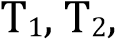 . The index of the depot is 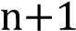. The tour traversed by the 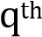 UAV, assuming it has targets, and the corresponding distance is given by

. (9)
(10)

The number of targets covered by each UAV added together should be equal to the total number of targets on the map.

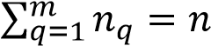 (11)

In the MTSP, the objective is to minimize the total mission time .

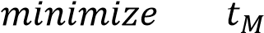 (12)

The mission time is equal to the time taken by the last UAV to get back to the depot, which is proportional to the distance travelled by this UAV, since the speed of all the UAVs are assumed to be equal. Thus, the mission time is proportional to the maximum distance travelled amongst the m UAVs, D_{max}.

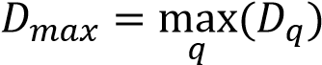 (13)
Hence, the objective can be rewritten as

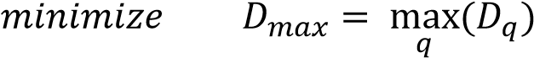 (14)

From eq. 14, it is clear why the MTSP is called the min-max optimization problem.

(Sathyan, 2015)
5. RESEARCH RESULTS
5.1 The Traveling Salesman Problem
Since each RET participant generated a different set of parameters for the number of generations (i), population size (j) and crossover fraction (s), the results from each set of parameters is shown in the figures below. Figure 9a shows Mrs. Lindsey’s results for the comparison of MATLAB GA and MY_GA. Figure 9b shows Mrs. Francis’ results for the comparison of MATLAB GA and MY_GA.
 | 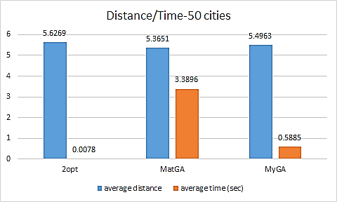
Figure 9a Mrs. Lindsey’s Comparison Data  i=552, j=197, s=0.9 | Figure 9b Mrs. Francis’ Comparison Data  i=592, j=178, s=1.0

The results of both sets parameters clearly show that if time is important, the 2-Opt algorithm is much faster than either of the Genetic Algorithms. For 50 cities over 100 iterations, the GAs both reduced the distance needed for a path but the MATLAB GA greatly increased the time needed to generate the path. The MY_GA managed to reduce the distance with a much smaller increase in time.

5.2 Multiple Traveling Salesman Problem
The RET participants finally tested their sets of parameters in two Multiple Traveling Salesman Genetic Algorithms. Data was compared for the generic MATLAB GA and the MY_GA for one depot and 2, 3,or 4 clusters. The cluster data for Mrs. Francis is shown in Table 3 and Mrs. Francis’ cluster maps are shown in Figure 10. Table 4 and Figure 11 show Mrs. Lindsey’s data and maps. The MATLAB data and maps are displayed in Table 5 and Figure 12.
Table 3. Cluster Data for Mrs. Francis
MY MTSP  Mrs. Francis’ Results  i = 592, j = 178, s = 1 | 2 Clusters | 3 Clusters | 4 Clusters
 | Distance | Distance | Distance
Cluster 1 | 2.7899 | 1.5646 | 1.9359
Cluster 2 | 3.2213 | 2.1672 | 1.7424
Cluster 3 |  | 2.6826 | 1.5646
Cluster 4 |  |  | 1.8730
Total Distance | 6.0112 | 6.4144 | 7.1159
Optimal Distance | 3.2213 | 2.6826 | 1.9359
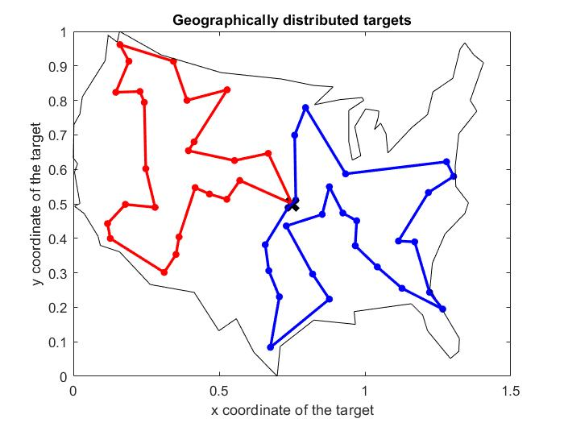 | 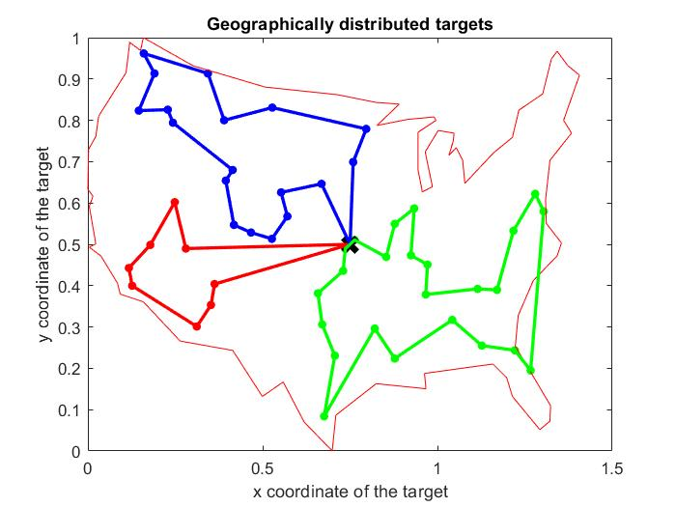 | 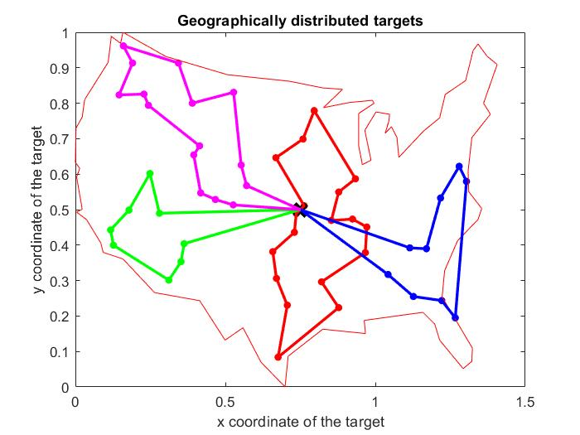
2 clusters | 3 clusters | 4 clusters

Figure 10 Mrs. Francis’ Cluster Maps
Table 4. Cluster Data for Mrs. Lindsey

MY MTSP  Mrs. Lindsey’s Results  i = 552, j = 197, s = .9 | 2 Clusters | 3 Clusters | 4 Clusters
 | Distance | Distance | Distance
Cluster 1 | 3.1311 | 1.9853 | 2.6609
Cluster 2 | 2.8473 | 2.7008 | 1.1593
Cluster 3 |  | 1.7447 | 2.0122
Cluster 4 |  |  | 1.4756
Total Distance | 5.9785 | 6.4308 | 7.3079
Optimal Distance | 3.1311 | 2.7008 | 2.6609
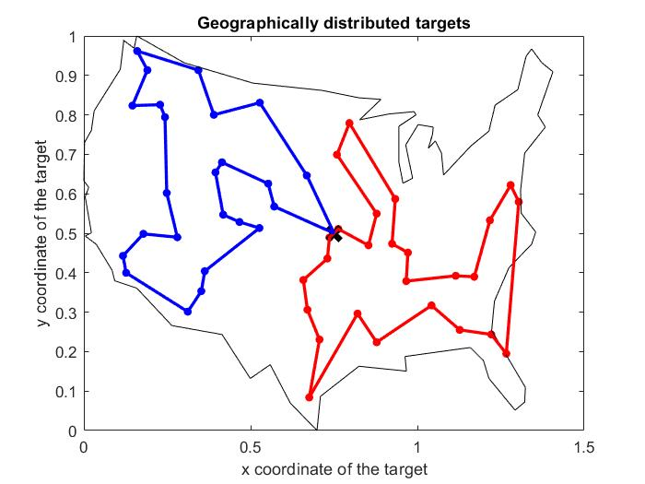 | 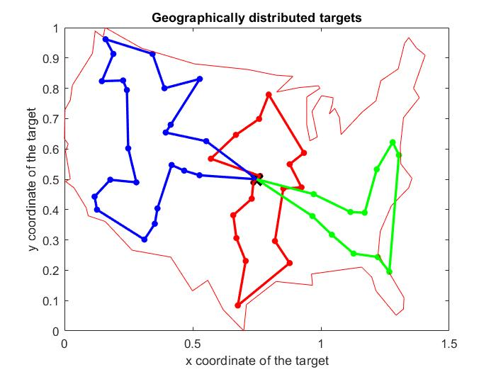 | 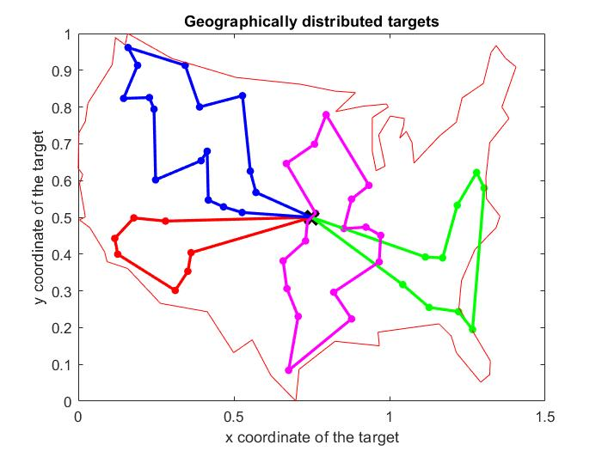
2 clusters | 3 clusters | 4 clusters

Figure 11 Mrs. Lindsey’s Cluster Maps

Table 5. Cluster Data for MATLAB

MTSPOF –  MATLAB GA | 2 Clusters | 3 Clusters | 4 Clusters
 | Distance | Distance | Distance
Cluster 1 | 2.5007 | 1.9622 | 2.1601
Cluster 2 | 3.3885 | 0.9007 | 1.8897
Cluster 3 |  | 3.5745 | 2.8389
Cluster 4 |  |  | 0.7097
Total Distance | 5.8892 | 6.4374 | 6.9081
Optimal Distance | 3.3885 | 3.5745 | 2.8389
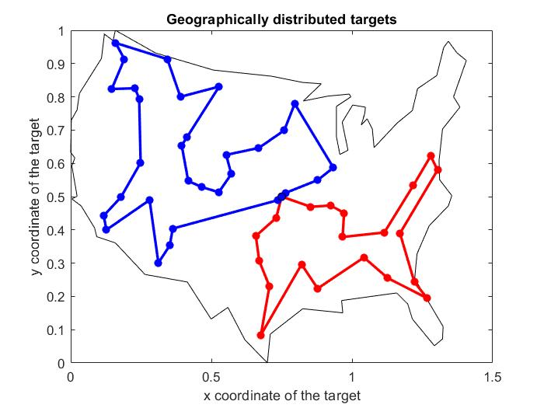 | 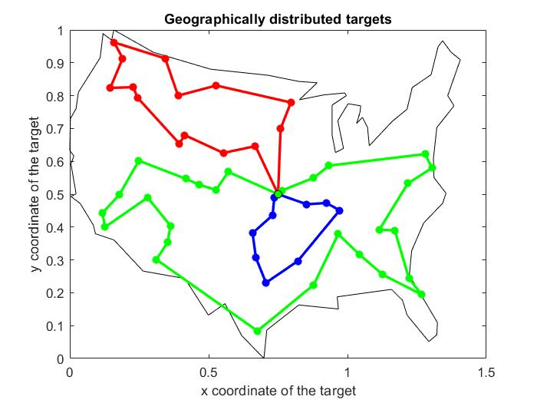 | 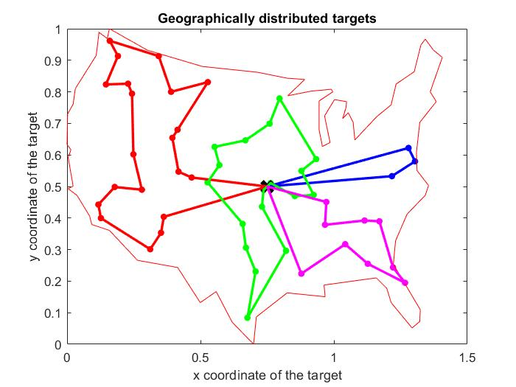
2 clusters | 3 clusters | 4 clusters

Figure 12 MATLAB Cluster Maps

In looking at the individual cluster distances, the MY_GA clusters tended to have more closely comparable distances with a lower variation than the MATLAB GA. This was seemed to be more evident as the number of clusters increased. The range of distances is shown in Table 6. The variance in range indicates how wide the spread of distances is between clusters or whether the short paths are evenly spaced. A more efficient set of paths would have fairly even distances for each cluster which would result in a smaller range of cluster distances. The MATLAB clusters tend to have one path that is much shorter than the others. This is not an optimal distribution of work.
Table 6. Range of Cluster Distances

 | 2 Cluster Range | 3 Cluster Range | 4 Cluster Range
Mrs. Francis | .4314 | 1.118 | .3713
Mrs. Lindsey | .2838 | .9561 | 1.5016
MATLAB GA | .8878 | 2.6738 | 2.1292

6. RESEARCH CONCLUSIONS
In all of the testing, the modified algorithm MY_GA showed the better balance of distance and time for both single and multiple Traveling Salesmen. It reduced the distance of the path while increasing time only slightly. Since the ultimate goal of the research is to produce an algorithm that generates useful paths for drones to employ, distance and time are both important parameters to consider in conjunction with limited battery life. MY_GA seems to be a good starting point for developing a better algorithm.
7. RECOMMENDATIONS FOR FUTURE RESEARCH
One recommendation for future research could include testing for a larger group of cities and analyzing the combined effect on distance and time. For MTSP, the maps indicate that there is often little balance in the number of cities in the clusters. It might be possible to add a 2-Opt to test if switching cities between clusters would further minimize the maximum distance
8. CLASSROOM IMPLEMENTATION PLAN
8.1 Mrs. Francis’ Classroom Implementation Plan
Mrs. Francis's class is an 8th grade Gifted STEM class. The unit will focus on optimization of time at an amusement park. To prepare for the challenge, students will use mathematical modeling to solve a real-world problem. Students build a graph-theory model of their city's map to determine the best route to school. Students evaluate and reflect on their solutions. Students follow the Engineering Design Process to determine the optimal path for their assigned client. Students create a graph theory model of Kings Island and use their client descriptions and constraints to solve the challenge. To test their solutions, students will enter their parameters into MatLab to determine if their path is optimal. A second iteration will include wait times for the roller coasters. Students will have to take in account the wait times to determine the best path. As an extension, class will use the information gathered to come up with an app concept for a Roller Coaster Optimization App.
8.2 Mrs. Lindsey’s Classroom Implementation Plan
Mrs. Lindsey’s class is Algebra III, a course coming between Algebra II and Precalculus. The unit will focus on optimization of a tunnel design. To prepare for the unit, students will be studying equations of functions that will eventually form the toolkit for designing a mathematical model for an efficient road tunnel based on constraints of car size and road requirements. The students will preview the Hook by watching short videos of several tunnels in various parts of the world that explain some of the design decisions made and why the choices were important. As the students continue their study of function equations, they will put them to use first in piecewise functions that combine parts of several functions. Then they will use piecewise functions to represent various real world situations. The Challenge will be to use the Engineering Design Process to use piecewise functions to mathematically model a tunnel and build a working scale model that allows safe passage of their cars. Tunnels will be tested to see if they can allow passage of the cars and if they can hold up a load that mimics a mountain. The ultimate goal is for students to see the usefulness of algebra in modeling the real world.
9. ACKNOWLEDGEMENTS
The RET program, “Challenge-Based Learning and Engineering Design Process Enhanced Research Experiences for Secondary and Community College In-Service Teachers” is funded by the National Science Foundation, Grant ID# EEC-1710826.
Faculty Mentors: Dr. Jeffrey Kastner and Dr. Manish Kumar
Graduate Research Assistant: Mr. Siddharth Sridhar
RET Project Director and Principal Investigator, Dr. Anant Kukreti
RET Co-Project Director and Co-Principal Investigator, Dr. Margaret Kupferle
RET Resource Persons and Grant Coordinators, Ms. Debbie Liberi and Kristin Barnes
RET Resource Engineering Teacher, Pamela Truesdell

10. BIBLIOGRAPHY
Alemayeyu,S.T., Kim, J. (2017). “Efficient Nearest Neighbor Heuristic TSP Algorithms for Reducing Data Acquisition Latency of UAV Relay WSN.” Wireless Personal Communications. Springer, New York. Vol. 95, No. 3: 3271-3285.
Applegate, D.L., Bixby, R.E., Chvatal, V., and Cook, W.J. (2007). The Traveling Salesman Problem. Princeton University Press.
Haupt, R.L. and Haupt, S.E. (1998). Practical Genetic Algorithms. John Wiley & Sons, Inc.
Hou, M., and Liu, D. (2012). “A Novel Method for Solving the Multiple Traveling Salesmen Problem with Multiple Depots.” Chinese Science Bulletin. Vol. 57, No. 15: 1886-1892.
Johnson, D.S. and McGeoch, L.A (1997). “The Traveling Salesman Problem: A Case Study in Local Optimization”. Local Search in Combinatorial Optimization, E. H. L. Aarts and J. K. Lenstra (eds.). John Wiley and Sons, London. pp. 215-310.
Kramer, O. (2017).Genetic Algorithm Essentials. Springer International, Cham, Switzerland.

Kuang, E. (2012). “A 2-opt-based Heuristic for the Hierarchical Traveling Salesman Problem.”

Lin, S. and Kernighan, B.W. (1973). “An Effective Heuristic Algorithm for the Traveling-Salesman Problem”. Operations Research. Vol. 21, No. 2, pp.498-515.
Sathyan, A., Boone, N. and Cohen, K. (2015). “Comparison of Approximate Approaches to Solving the Traveling Salesman Problem and its Application to UAV Swarming”. International Journal of Unmanned Systems Engineering. Vol. 3, No. 1,pp. 1-16.
11. APPENDIX I: NOMENCLATURE USED
NP-hard – a question that can be solved in non-deterministic polynomial time
Two-Opt - an algorithm that exchanges a pair of edges between cities that will stop when a tour is reached that connects all the cities, routes back to the initial point, and when the distance cannot be improved with any further exchanges
Genetic Algorithm (GA) – an algorithm that relies on the mechanisms behind organic evolution to find an optimal solution
Nearest Neighbor (NN) - a heuristic in which the next city traveled to is always the closest one that has not been visited
MATLAB – software for engineers where the testing for this research was completed
Optimization – finding the maximum or minimum value of a function
Traveling Salesman Problem (TSP) – a question of finding an optimal route for a salesman to travel that starts at one city and ends at the same city. The problem is to find the shortest distance to visit all the cities once and has the least cost associated with the trip.
Multiple Traveling Salesman Problem (MTSP) - a question of finding an optimal route in which multiple salesmen and/or depots are used.
D – Total distance traveled by a traveling salesman following tour T, which is also the cost function
d_{ij} – Distance between the i^{th} and j^{th} targets
E_{i,j} – Length of the edge connecting the targets in the i^{th} and j^{th} tour T
n – Number of targets
N – Set of indices defining the targets
T - Vector representing the tour
12. APPENDIX II: RESEARCH SCHEDULE
Week 2: Training with MATLAB – basics of programming and reading program
Introduction to TSP, NN, 2-Opt
Week 3: Introduction to Genetic Algorithm – begin to test various parameters
Week 4: GA Research – analyze initial GA data and choose optimal parameters and test data
Week 5: Compare data from GA and 2-Opt. Debugging for optimized solutions. Introduction to
Clustering.
Week 6: Finalize data and complete reports, posters, PPT, video

13. APPENDIX III: UNIT PLAN FOR MRS. BETH FRANCIS

Name: Beth Francis | Contact Info: francisb@felicityschools.org | Date:6/21/2018

Unit Number and Title: Unit 1: A Day at Kingslsland

Grade Level: | 8
Subject Area: | Gifted STEM

Total Estimated Duration of Entire Unit: | 8-10 45 minute classes

Part 1: Designing the Unit
- Unit Academic Standards (Identify which standards: NGSS, OLS and/or CCSS. Cut and paste from NGSS, OLS and/or CCSS and be sure to include letter and/or number identifiers.):
NCTM’s Principles and Standards for School Mathematics
Number and Operations Standard: Compute fluently and make reasonable estimates
Geometry Standard:
- Specify locations and describe spatial relationships using coordinate geometry and other representational systems
- Use visualization, spatial reasoning, and geometric modeling to solve problems
Measurement Standard:
- Understand measurable attributes of objects and the units, systems, and processes of measurement
- Apply appropriate techniques, tools, and formulas to determine measurements.
Problem Solving Standard:
- Apply and adapt a variety of appropriate strategies to solve problems.
- Solve problems that arise in mathematics and in other contexts.
- Representation: Use representations to model and interpret physical, social and mathematical phenomena
Common Core State Standards for Mathematics
- Quantities • Reason quantitatively and use units to solve problems
- Modeling with Geometry • Apply geometric concepts in modeling situations
- International Technology and Engineering Educators Association’s Standards for Technical Literacy
- Standard 2: Students will develop an understanding of the core concepts of technology.
- Standard 3: Students will develop an understanding of the relationships among technologies and the connections between technology and other fields of study.

- Unit Summary
The Big Idea (including global relevance):
Optimization
People always want to spend the least amount time and resources and get the best results. Experts have developed a way to use technology to help optimize our lives. Businesses use models to maximize profits and to plan transportation routes. Agricultural business use models to improve crop yield. Manufacturing use models to improve processes and systems.

The (anticipated) Essential Questions: List 3 or more questions your students are likely to generate on their own. (Highlight in yellow the one selected to define the Challenge):
- How can we get the most for my money spent on entertainment?
- How can I get the most entertainment for my time spent?
- How can I maximize my access to needs, or entertainment?
- How can I minimize my wait time?

- Unit Context
Justification for Selection of Content– Check all that apply:
☐ Students previously scored poorly on standardized tests, end-of term test or any other test given in the school or district on this content.
☐ Misconceptions regarding this content are prevalent.
☐ Content is suited well for teaching via CBL and EDP pedagogies.
☐ The selected content follows the pacing guide for when this content is scheduled to be taught during the school year. (Unit 1 covers atomic structure because it is taught in October when I should be conducting my first unit.)
☐ Other reason(s) _____________________________________________________________
_____________________________________________________________________________

The Hook: (Describe in a few sentences how you will use a “hook” to introduce the Big Idea in a compelling way that draws students into the topic.)

Start with video https://www.youtube.com/watch?v=2y4fvzJC_Mw Then show https://www.youtube.com/watch?v=HwNy7JpgWHg After viewing video discuss how the information for the video was determined. Which leads to identifying the Big Idea and starting the CBL process.

The Challenge and Constraints:

☐ Product or ☐ Process (Check one)

Description of Challenge (Either Product or Process is clearly explained below): | List the Constraints Applied
Design the best path to visit all the Roller coasters at Kings Island in a given amount of time.  Students create an optimization plan or flow chart that works for different levels of thrill seeking. Each group will get an specific client. | - Time Limit at park  - Must alternate between Thrill levels (Level 1-5)  - Time at KI must include at least 1 food stop and 2 restroom breaks

Teacher’s Anticipated Guiding Questions (that apply to the Challenge and may change with student input.):
- How many roller coasters are at Kings Island?
- What is the distance between the roller coasters?
- What is graph theory?
- How can graph theory help solve this challenge?
- How can math help solve this challenge?
- What is computer algorithmic thinking?
- What are the parts of an app?
- What is optimization?
- What careers involve optimization?
- What is engineering?
- Would buying a jumping in line pass at Kings Island be worth the money?
- What is the best way to utilize my time at Kings Island to get the best bang for my buck?
- How can I maximize my time on ride and minimize my wait time in line during a day at Kings Island?

4. EDP: Use the diagram below to help you complete this section.
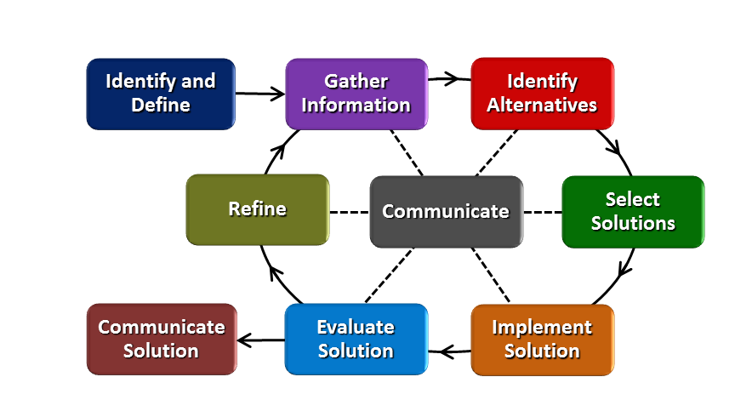
How will students test or implement the solution? What is the evidence that the solution worked? Describe how the iterative process from the EDP applies to your Challenge.
Students will test their solution by inserting their variables into the TSP algorithm and see if their solution is the most optimal.

How will students present or defend the solution? Describe if any formal training or resource guides will be provided to the students for best practices (e.g., poster, flyer, video, advertisement, etc.) used to present work.
Students will create a presentation for their client explaining their solution.

What academic content is being taught through this Challenge?
- Mathematic Modeling
- Graph theory
- Computer Algorithmic Thinking
Mathematical Practices
1. Make sense of problems and persevere in solving them.
2. Reason abstractly and quantitatively.
3. Construct viable arguments and critique the reasoning of others.
4. Model with mathematics.
5. Use appropriate tools strategically.
6. Attend to precision.
7. Look for and make use of structure.
8. Look for and express regularity in repeated reasoning.
Assessment and EDP:
Using the diagram above, identify any places in the EDP where assessments should take place, as it applies to your Challenge. Describe below what kinds of assessment are most appropriate.
What EDP Processes are ideal for conducting an Assessment? (List ones that apply.) | List the type of Assessment (Rubric, Diagram, Checklist, Model, Q/A etc.) Check box to indicate whether it is formative or summative.
Communicate_________  Challenge  Gather Information | Engineering Notebook EDP Documentation  ☐ formative ☐ summative  Solution Presentation Rubric ☐ formative ☐ summative  Choose your Best Path Solution ☐ formative ☐ summative

Check below which characteristic(s) of this Challenge will be incorporated in its implementation using EDP. (Check all that apply.)
☐ Has clear constraints that limit the solutions
☐ Will produce than one possible solution that works
☐ Includes the ability to refine or optimize solutions
☐ Assesses science or math content
☐ Includes Math applications
☐ Involves use of graphs
☐ Requires analysis of data
☐ Includes student led communication of findings

5. ACS (Real world applications; career connections; societal impact):
Place an X on the continuum to indicate where this Challenge belongs in the context of real world applications:
Abstract or Loosely Applies to the Real World | |--------------------------------------|--------------------------------------X| | Strongly Applies to the Real World

Provide a brief rationale for where you placed the X: People always want to save money and time. When it comes to engineering these are the two things that drive the research and development. Optimization is a crucial part of the real world.
What activities in this Unit apply to real world context? Optimizing our world using mathematics and computer programming. ________________________________________

Place an X on the continuum to indicate where this Challenge belongs in the context of societal impact:
Shows Little or No Societal Impact | |-------------------------------------|---------------------------------------X| | Strongly Shows Societal Impact

Provide a brief rationale for where you placed the X: Waiting in long lines takes lots of time. Time is something you can never get back. Finding ways to save time and money should be a priority to society not just in the engineering world.

What activities in this Unit apply to societal impact? Students can relate to having to wait in lines. During the hook students will be exposed to many pictures that show long lines at various parks.

Careers: What careers will you introduce (and how) to the students that are related to the Challenge? (Examples: career research assignment, guest speakers, field trips, Skype with a professional, etc.) Careers-Performance Optimization Engineer, Optimization Analyst, Mathematician, Computer Programming, Civil Engineering. During challenge day either visit Jeff and Sid at the lab to test solutions or have them come to school to run the tests.
Extension: Students research the careers related to the challenge.

6. Misconceptions:

7. Unit Lessons and Activities: (Provide a tentative timeline with a breakdown for Lessons 1 and 2. Provide the Lesson #’s and Activity #’s for when the Challenge Based Learning (CBL) and Engineering Design Process (EDP) are embedded in the unit.)
Lesson 1: Using Math for Optimization
In Activity 1, Students will be introduced the Big Idea of optimization in our world. Then they develop the Essential Question, Challenge and the guiding questions. In Activity 2, students are introduced to graph theory as a way for optimization.
Activity 1: CBL: Big Idea, Essential Question, Challenge, Guiding Question
Administer Pre-Assessment :
    - Hook:
    - Big Idea: Optimization of time
    - Essential Questions
    - Common Essential Question:
    - Challenge

Activity 2: Choose your Best Way
In this lesson on using mathematical modeling to solve real-world problems, students work in teams to build a graph-theory model of their city’s map, then use it to find the best route to school, evaluate their solutions, and present their reflections to the class. Lesson from http://teachers.egfi-k12.org/wp-content/uploads/2017/10/choosebestway.pdf
Lesson 2: EDP In Action
Students use the EDP to solve the chosen challenge. Activity 3 has the students gathering information for the challenge. In Activity 4, students create an optimization plan for their assigned client.
Activity 3: Kings Island Research
Students will create a graph-theory model of Kings Islands map to prepare for challenge.
Activity 4: Roller Coaster App Challenge
Students create an optimization plan for a day at Kings Island that works for a specific client. Clients will be different levels of thrill seekers. As a class, we will create a flow chart for an Roller Coaster Optimization App.
CBL-Activity 1 and 4 EDP Activity 3 and 4

8. Keywords:

9. Additional Resources:

10. Pre-Unit and Post-Unit Assessment Instruments:

11. Poster | 12. Video (Link here.)

If you are a science teacher, check the boxes below that apply:

Next Generation Science Standards (NGSS)
Science and Engineering Practices (Check all that apply) | Crosscutting Concepts (Check all that apply)
☐ Asking questions (for science) and defining problems (for engineering) | ☐ Patterns
☐ Developing and using models | ☐ Cause and effect
☐ Planning and carrying out investigations | ☐ Scale, proportion, and quantity
☐ Analyzing and interpreting data | ☐ Systems and system models
☐ Using mathematics and computational thinking | ☐ Energy and matter: Flows, cycles, and conservation
☐ Constructing explanations (for science) and designing solutions (for engineering) | ☐ Structure and function.
☐ Engaging in argument from evidence | ☐ Stability and change.
☐ Obtaining, evaluating, and communicating information

If you are a science teacher, check the boxes below that apply:
Ohio’s Learning Standards for Science (OLS)
Expectations for Learning - Cognitive Demands (Check all that apply)
☐ Designing Technological/Engineering Solutions Using Science concepts (T)
☐ Demonstrating Science Knowledge (D)
☐ Interpreting and Communicating Science Concepts (C)
☐ Recalling Accurate Science (R)

If you are a math teacher, check the boxes below that apply:
Ohio’s Learning Standards for Math (OLS) or
Common Core State Standards -- Mathematics (CCSS)
Standards for Mathematical Practice (Check all that apply)
☐ Make sense of problems and persevere in solving them | ☐ Use appropriate tools strategically
☐ Reason abstractly and quantitatively | ☐ Attend to precision
☐ Construct viable arguments and critique the reasoning of others | ☐ Look for and make use of structure
☐ Model with mathematics | ☐ Look for and express regularity in repeated reasoning

Part 2: Post Implementation- Reflection on the Unit
Results: Evidence of Growth in Student Learning - After the Unit has been taught and the Post-Unit Assessment Instrument has been used to assess student growth in learning, the teacher must analyze the data and determine whether or not student growth in learning occurred. Present all documents used to collect and organize Post- Unit evaluation data such as graphs or charts. Provide a written analysis in sentence or paragraph form which provides the evidence that student growth in learning took place. Please present results and, if applicable, student work (as a hyperlink) used as evidence after the Unit has been taught.

Please include:
- Any documents used to collect and organize post unit evaluation data. (charts, graphs and /or tables etc.)
- An analysis of data used to measure growth in student learning providing evidence that student learning occurred. (Sentence or paragraph form.)
- Other forms of assessment that demonstrate evidence of learning.
- Anecdotal information from student feedback.

Reflection: Reflections: Reflect upon the successes of teaching in this Unit in 5 or more sentences in the form of a narrative. Consider the following questions:
- Why did you select this content for the Unit?
- Was the purpose for selecting the Unit met? If yes, provide student learning related evidence. If not, provide possible reasons.
- Did the students find a solution or solutions that resulted in concrete meaningful action for the Unit’s Challenge? Hyperlink examples of student solutions as evidence.
- What does the data indicate about growth in student learning?
- What would you change if you re-taught this Unit?
- Would you teach this Unit again? Why or why not?

Name: Beth Francis | Contact Info: francisb@felicityschools.org | Date:06/27/2018

Lesson Title: Using Math for Optimization | Unit #:  1 | Lesson #:  1 | Activity #:  1
Activity Title: CBL: Big Idea, Essential Question, Challenge, Guiding Question

Estimated Lesson Duration: | 8-10 45 minute classes
Estimated Activity Duration: | 1-2 45 minute classes

Setting: | Classroom

Activity Objectives:
Students will develop essential questions when given a big idea.
Students will develop one common essential question.
Students will create a challenge from an essential question.
Students will develop guiding questions to aid in solving the challenge.

Activity Guiding Questions:
- What is the difference between a project and a challenge?
- What is the big idea?
- What is an essential question?
- Is it an open-ended question or can it be answered with a quick search?
- Is there more than one solution?
- What do we need to know in order to solve the challenge (guiding questions)?

Next Generation Science Standards (NGSS)
Science and Engineering Practices (Check all that apply) | Crosscutting Concepts (Check all that apply)
☒ Asking questions (for science) and defining problems (for engineering) | ☐ Patterns
☐ Developing and using models | ☐ Cause and effect
☐ Planning and carrying out investigations | ☐ Scale, proportion, and quantity
☐ Analyzing and interpreting data | ☐ Systems and system models
☐ Using mathematics and computational thinking | ☐ Energy and matter: Flows, cycles, and conservation
☐ Constructing explanations (for science) and designing solutions (for engineering) | ☐ Structure and function.
☐ Engaging in argument from evidence | ☐ Stability and change.
X Obtaining, evaluating, and communicating information

Ohio’s New Learning Standards for Science (ONLS)
Expectations for Learning - Cognitive Demands (Check all that apply)
☐ Designing Technological/Engineering Solutions Using Science concepts (T)
☐ Demonstrating Science Knowledge (D)
☐ Interpreting and Communicating Science Concepts (C)
☐ Recalling Accurate Science (R)

Common Core State Standards -- Mathematics (CCSS)
Standards for Mathematical Practice (Check all that apply)
X Make sense of problems and persevere in solving them | ☐ Use appropriate tools strategically
☐ Reason abstractly and quantitatively | ☐ Attend to precision
☐ Construct viable arguments and critique the reasoning of others | ☐ Look for and make use of structure
☐ Model with mathematics | ☐ Look for and express regularity in repeated reasoning

Unit Academic Standards (NGSS, ONLS and/or CCSS):
NCTM’s Principles and Standards for School Mathematics
Number and Operations Standard: Compute fluently and make reasonable estimates
Geometry Standard:
· Specify locations and describe spatial relationships using coordinate geometry and other representational systems
· Use visualization, spatial reasoning, and geometric modeling to solve problems
Measurement Standard:
· Understand measurable attributes of objects and the units, systems, and processes of measurement
· Apply appropriate techniques, tools, and formulas to determine measurements.
Problem Solving Standard:
· Apply and adapt a variety of appropriate strategies to solve problems.
· Solve problems that arise in mathematics and in other contexts.
· Representation: Use representations to model and interpret physical, social and mathematical phenomena
Common Core State Standards for Mathematics
· Quantities • Reason quantitatively and use units to solve problems
· Modeling with Geometry • Apply geometric concepts in modeling situations
· International Technology and Engineering Educators Association’s Standards for Technical Literacy
· Standard 2: Students will develop an understanding of the core concepts of technology.
· Standard 3: Students will develop an understanding of the relationships among technologies and the connections between technology and other fields of study.

Materials: (Link Handouts, Power Points, Resources, Websites, Supplies)
- Unit Pre-assessment
- Hook-BI-EQ-Challenge Handout
- Dry erase markers & Boards or Large Paper and Colored Markers

Teacher Advance Preparation:
- Be sure to have the above handouts printed.
- Check videos to make sure they work
Activity Procedures:
- Administer the pre-assessment.
- Introduce the hook.
- After the hook, give students the big idea.
- Brainstorm session
  - List on paper what you know about the big idea for three minutes and provide no fewer than five items. (independent work)
  - Take turn sharing your thoughts (what you know) about the big idea for four minutes. The teacher will record your input on the screen.
- Essential Question session (group work)
  - Based on the big idea, brainstorm essential questions that interest you. List at least five essential questions that clarify the big idea. Each group member should have a different color marker. Each color should be present on the paper.
- Common Essential Question (whole class)
  - Teams will take turns sharing their developed questions. As teams are sharing, other groups will highlight common themes or words on their paper. After all groups have shared, as students to develop a common essential question by combining like themes or words. This should be done as a whole class.
- Challenge (whole class)
  - After the essential question is developed, students will begin brainstorming possible challenges. They probably had some in mind before this section. They will be eager to share with you. Sometimes, students may need additional information to create a challenge. A quick google search on the smartboard will help them.
- Guiding Questions (whole class)
  - Create a concept map of questions that will help solve the challenge. This can be done on the back of this paper. The concept map should include questions for the engineering design process portion and questions for the concepts we need to learn in order to solve the challenge.
Formative Assessments: Link the items in the Activities that will be used as formative assessments.

CBL Graphic Organizer

Summative Assessments: These are optional; there may be summative assessments at the end of a set of Activities or only at the end of the entire Unit.

Pre/Post Assessment
Differentiation: Describe how you modified parts of the Lesson to support the needs of different learners.
Refer to Activity Template for details.

Reflection: Reflect upon the successes and shortcomings of the lesson.

Name: Beth Francis | Contact Info: francisb@felicityschools.org | Date:6/27/2018

Lesson Title : Using Math for Optimization | Unit #  1 | Lesson #:  1 | Activity #:  2
Activity Title: Choose Your Best Way

Estimated Lesson Duration: | 8-10 45 minute class periods
Estimated Activity Duration: | 2-45 minute class periods

Setting: | classroom

Activity Objectives:
Students will be able to:
- Identify the key components of optimization
- Explain graph theory
- Explain the relationship between graph theory and optimization
- Build a mathematical model to solve a problem
- Evaluate solutions
- Present reflections

Activity Guiding Questions:
· What is graph theory?
· How can graph theory help solve this challenge?
· How can math help solve this challenge?
· What is computer algorithmic thinking?
· What is optimization?

Next Generation Science Standards (NGSS)
Science and Engineering Practices (Check all that apply) | Crosscutting Concepts (Check all that apply)
☐ Asking questions (for science) and defining problems (for engineering) | ☐ Patterns
X Developing and using models | ☐ Cause and effect
☐ Planning and carrying out investigations | ☐ Scale, proportion, and quantity
☐ Analyzing and interpreting data | X Systems and system models
X Using mathematics and computational thinking | ☐ Energy and matter: Flows, cycles, and conservation
☐ Constructing explanations (for science) and designing solutions (for engineering) | ☐ Structure and function.
☐ Engaging in argument from evidence | ☐ Stability and change.
☐ Obtaining, evaluating, and communicating information

Ohio’s Learning Standards for Science (OLS)
Expectations for Learning - Cognitive Demands (Check all that apply)
☐ Designing Technological/Engineering Solutions Using Science concepts (T)
☐ Demonstrating Science Knowledge (D)
☐ Interpreting and Communicating Science Concepts (C)
☐ Recalling Accurate Science (R)

Ohio’s Learning Standards for Math (OLS) and/or
Common Core State Standards -- Mathematics (CCSS)
Standards for Mathematical Practice (Check all that apply)
☐ Make sense of problems and persevere in solving them | ☐ Use appropriate tools strategically
☐ Reason abstractly and quantitatively | ☐ Attend to precision
☐ Construct viable arguments and critique the reasoning of others | ☐ Look for and make use of structure
☐ Model with mathematics | ☐ Look for and express regularity in repeated reasoning

Unit Academic Standards (NGSS, OLS and/or CCSS):
NCTM’s Principles and Standards for School Mathematics
Number and Operations Standard: Compute fluently and make reasonable estimates
Geometry Standard:
· Specify locations and describe spatial relationships using coordinate geometry and other representational systems
· Use visualization, spatial reasoning, and geometric modeling to solve problems
Measurement Standard:
· Understand measurable attributes of objects and the units, systems, and processes of measurement
· Apply appropriate techniques, tools, and formulas to determine measurements.
Problem Solving Standard:
· Apply and adapt a variety of appropriate strategies to solve problems.
· Solve problems that arise in mathematics and in other contexts.
· Representation: Use representations to model and interpret physical, social and mathematical phenomena
Common Core State Standards for Mathematics
· Quantities • Reason quantitatively and use units to solve problems
· Modeling with Geometry • Apply geometric concepts in modeling situations
· International Technology and Engineering Educators Association’s Standards for Technical Literacy
· Standard 2: Students will develop an understanding of the core concepts of technology.
· Standard 3: Students will develop an understanding of the relationships among technologies and the connections between technology and other fields of study.

Materials: (Link Handouts, Power Points, Resources, Websites, Supplies)
Student Resource Sheet
Student Worksheet
Map of school
One set of materials for each group of students: a city map, ruler, eraser, pencil, pencil sharpener, marker
Internet Resources
Additional Resources if needed:
TryComputing (www.trycomputing.org)
Graph Theory tutorials of the University of Tennessee at Martin (http:/www.utm.edu/departments/math/graph)
Video on Intro to Basics of Neural Networks: https://www.youtube.com/watch?v=-qtwAzLb6RU
Intro to Neural Networks: https://www.youtube.com/watch?v=ZzWaow1Rvho

Teacher Advance Preparation:
Make sure links work.
Suggested Advance option-The teacher makes a presentation using electronic map software or automotive navigation system to give students a deep impression.

Activity Procedures: Full Lesson plan can be found http://teachers.egfi-k12.org/wp-content/uploads/2017/10/choosebestway.pdf
1.Hand out Student Reference Sheet and read and discuss as a class or provide it as reading material for the prior night’s homework.
2. Divide students into engineering groups of four or five.
3. To introduce the lesson, discuss with students the use of networks in daily life. For instance, give them a map of the school and have them draw their path for the day starting with when and where they enter the building. Discuss if they think their path is optimal. Brainstorm ways to make it better. Continue the discussion by showing images of road and rail systems, discussing connections via social media and computer networks.
4. Hand out Student Worksheet: Search the Shortest Path. Student work in their engineering groups to complete the following tasks:
Graph Layout
Read the city map carefully.
1. Use a marker or pen to circle your school and home of each member in your team in the map. Find the shortest roads between each pair of the places.
2. Sketch the corresponding graph
3. Fill in the blanks with the words “places” and “roads”.
The edges of this graph represent __________, while the vertexes represent __________.
4. Re-read the student resource sheets. Then discuss whether your graph contains an Eulerian Path or an Eulerian Circuit.
What about Hamiltonian Path and Hamiltonian Circuit?
5. In graph theory, if every pair of distinct vertices is connected by a unique edge in a graph, then the graph is called a complete graph.
Is your graph a complete graph, or does your graph contain such a complete graph?
6. Measure the distances between each pair of the places and fill in the data on the following sheet. Please pay attention to the scale of the map. If there is no direct way between any two places, write down “-” instead.

7. Now, do you think you can remake the graph just using the data in this sheet? If your answer is yes, try to do it. Then you may understand how a graph can be stored in computers. This is one possible solution, of course there are also many other solutions.
Search the Shortest Path
Assume that now you are at school with your friends and you forget to bring your homework. You need to go back home to pick it up and return to school. Since all of you are very good friends, you prefer to be together, that means you need to start from school to everyone’s home and finally return to school.
8. Think about how to find the shortest path that covers all of the places and write down your idea. Then try to find the shortest path.
9. Search the path using the following two different methods and calculate the length of the path.
First method:
Start the path from school and mark the school as visited;
The path always goes to the next place that does not be marked as visited and is the nearest neighboring place until all the places are marked as visited;
If there is no further place available, return to the last place;
Then path end at the school.
Second method:
Find the shortest distance between any two places and mark the places as visited;
Repeat to find another shortest distance between any two places (at least one of the places should not be marked), until all the places are marked as visited;
Check if any two places can be connected by the paths. If not, find the shortest way to connect them.
5. Student engineering teams complete the review and evaluation/reflection questions on their student worksheet and share their experiences with the class.
Formative Assessments: Link the items in the Activities that will be used as formative assessments.

Student Worksheet
Summative Assessments: These are optional; there may be summative assessments at the end of a set of Activities or only at the end of the entire Unit.

Differentiation: Describe how you modified parts of the Lesson to support the needs of different learners.
Refer to Activity Template for details.

Reflection: Reflect upon the successes and shortcomings of the lesson.

Name:Beth Francis | Contact Info: francisb@felicityschools.org | Date:6/28/2018

Lesson Title : EDP in Action | Unit #:  1 | Lesson #:  2 | Activity #:  3
Activity Title: Kings Island Research

Estimated Lesson Duration: | 8-10 45 minute class
Estimated Activity Duration: | 1-45 minute class

Setting: | classroom

Activity Objectives:
Students will:
- Identify and Define client needs
- Identify variables about Kings Island we need to know to solve challenge
- Create a graph-theory model of Kings Islands map to prepare for challenge.
- Calculate distances for model

Activity Guiding Questions:
- How many roller coasters are at Kings Island?
- What is the distance between the roller coasters?
- How can graph theory help solve this challenge?
- What is the graph theory model of Kings Island roller coasters look like?

Next Generation Science Standards (NGSS)
Science and Engineering Practices (Check all that apply) | Crosscutting Concepts (Check all that apply)
☐ Asking questions (for science) and defining problems (for engineering) | ☐ Patterns
☐ Developing and using models | ☐ Cause and effect
☐ Planning and carrying out investigations | ☐ Scale, proportion, and quantity
☐ Analyzing and interpreting data | ☐ Systems and system models
☐ Using mathematics and computational thinking | ☐ Energy and matter: Flows, cycles, and conservation
☐ Constructing explanations (for science) and designing solutions (for engineering) | ☐ Structure and function.
☐ Engaging in argument from evidence | ☐ Stability and change.
☐ Obtaining, evaluating, and communicating information

Ohio’s Learning Standards for Science (OLS)
Expectations for Learning - Cognitive Demands (Check all that apply)
☐ Designing Technological/Engineering Solutions Using Science concepts (T)
☐ Demonstrating Science Knowledge (D)
☐ Interpreting and Communicating Science Concepts (C)
☐ Recalling Accurate Science (R)

Ohio’s Learning Standards for Math (OLS) and/or
Common Core State Standards -- Mathematics (CCSS)
Standards for Mathematical Practice (Check all that apply)
☐ Make sense of problems and persevere in solving them | ☐ Use appropriate tools strategically
☐ Reason abstractly and quantitatively | ☐ Attend to precision
☐ Construct viable arguments and critique the reasoning of others | ☐ Look for and make use of structure
☐ Model with mathematics | ☐ Look for and express regularity in repeated reasoning

Unit Academic Standards (NGSS, OLS and/or CCSS):
NCTM’s Principles and Standards for School Mathematics
Number and Operations Standard: Compute fluently and make reasonable estimates
Geometry Standard:
· Specify locations and describe spatial relationships using coordinate geometry and other representational systems
· Use visualization, spatial reasoning, and geometric modeling to solve problems
Measurement Standard:
· Understand measurable attributes of objects and the units, systems, and processes of measurement
· Apply appropriate techniques, tools, and formulas to determine measurements.
Problem Solving Standard:
· Apply and adapt a variety of appropriate strategies to solve problems.
· Solve problems that arise in mathematics and in other contexts.
· Representation: Use representations to model and interpret physical, social and mathematical phenomena
Common Core State Standards for Mathematics
· Quantities • Reason quantitatively and use units to solve problems
· Modeling with Geometry • Apply geometric concepts in modeling situations
· International Technology and Engineering Educators Association’s Standards for Technical Literacy
· Standard 2: Students will develop an understanding of the core concepts of technology.
· Standard 3: Students will develop an understanding of the relationships among technologies and the connections between technology and other fields of study.

Materials: (Link Handouts, Power Points, Resources, Websites, Supplies)
Client descriptions
Map of Kings Island
ruler, eraser, pencil, pencil sharpener, marker

Teacher Advance Preparation:
Prepare client descriptions-

Activity Procedures:
- Client Phase: Give each engineering team their assigned client card. In engineering teams, students Identify and define their client based on given client description.
- Graph Layout Phase: In engineering teams, student complete the following procedures:
Read the Kings Island map carefully.
- Use a marker or pen to circle the entrance to KI and the roller coasters your client wants to ride.
- Find the shortest path between each pair of roller coasters.
- Sketch the corresponding graph.
- Measure the distances between each pair of roller coasters and create a data table to record your measurements. Pay close attention to the scale of the map.
- Create a table to record the distances and name of roller coasters to prepare for the challenge.

Summative Assessments: These are optional; there may be summative assessments at the end of a set of Activities or only at the end of the entire Unit.

Differentiation: Describe how you modified parts of the Lesson to support the needs of different learners.
Refer to Activity Template for details.

Reflection: Reflect upon the successes and shortcomings of the lesson.

Name: Beth Francis | Contact Info:francisb@felicityschools.org | Date:6/28/18

Lesson Title : EDP in Action | Unit #  1: | Lesson #:  2 | Activity #  4:
Activity Title: Roller Coaster App Challenge

Estimated Lesson Duration: | 8-10 45 minute classes
Estimated Activity Duration: | 2-3 45 minute classes
-

Setting: | classroom

Activity Objectives:
Students will be able to:
- Utilize the EDP to complete the challenge
- Present their findings
- Use their knowledge gained through the challenge to create a flowchart for an app idea with the whole class
- Demonstrate an understanding of graph theory
- Explain how math and computer programming relate to optimization

Activity Guiding Questions:
- What are the parts of the engineering design process?
- What is the challenge?
- What are the criteria and constraints?
- How do we pick which plan to share?
- What changes did you make to improve your plan?
- What changes would you make to improve your plan next time?
- What successes did you have during your challenges?
- What are some challenges you faced and how did you address them?
- What careers involve optimization?
- How can graph theory help solve this challenge?
- How can math help solve this challenge?
- What is computer algorithmic thinking?
- What are the parts of an app?

Next Generation Science Standards (NGSS)
Science and Engineering Practices (Check all that apply) | Crosscutting Concepts (Check all that apply)
☐ Asking questions (for science) and defining problems (for engineering) | ☐ Patterns
☐ Developing and using models | ☐ Cause and effect
☐ Planning and carrying out investigations | ☐ Scale, proportion, and quantity
☐ Analyzing and interpreting data | ☐ Systems and system models
☐ Using mathematics and computational thinking | ☐ Energy and matter: Flows, cycles, and conservation
☐ Constructing explanations (for science) and designing solutions (for engineering) | ☐ Structure and function.
☐ Engaging in argument from evidence | ☐ Stability and change.
☐ Obtaining, evaluating, and communicating information

Ohio’s Learning Standards for Science (OLS)
Expectations for Learning - Cognitive Demands (Check all that apply)
☐ Designing Technological/Engineering Solutions Using Science concepts (T)
☐ Demonstrating Science Knowledge (D)
☐ Interpreting and Communicating Science Concepts (C)
☐ Recalling Accurate Science (R)

Ohio’s Learning Standards for Math (OLS) and/or
Common Core State Standards -- Mathematics (CCSS)
Standards for Mathematical Practice (Check all that apply)
☐ Make sense of problems and persevere in solving them | ☐ Use appropriate tools strategically
☐ Reason abstractly and quantitatively | ☐ Attend to precision
☐ Construct viable arguments and critique the reasoning of others | ☐ Look for and make use of structure
☐ Model with mathematics | ☐ Look for and express regularity in repeated reasoning

Unit Academic Standards (NGSS, OLS and/or CCSS):
NCTM’s Principles and Standards for School Mathematics
Number and Operations Standard: Compute fluently and make reasonable estimates
Geometry Standard:
· Specify locations and describe spatial relationships using coordinate geometry and other representational systems
· Use visualization, spatial reasoning, and geometric modeling to solve problems
Measurement Standard:
· Understand measurable attributes of objects and the units, systems, and processes of measurement
· Apply appropriate techniques, tools, and formulas to determine measurements.
Problem Solving Standard:
· Apply and adapt a variety of appropriate strategies to solve problems.
· Solve problems that arise in mathematics and in other contexts.
· Representation: Use representations to model and interpret physical, social and mathematical phenomena
Common Core State Standards for Mathematics
· Quantities • Reason quantitatively and use units to solve problems
· Modeling with Geometry • Apply geometric concepts in modeling situations
· International Technology and Engineering Educators Association’s Standards for Technical Literacy
· Standard 2: Students will develop an understanding of the core concepts of technology.
· Standard 3: Students will develop an understanding of the relationships among technologies and the connections between technology and other fields of study.

Materials: (Link Handouts, Power Points, Resources, Websites, Supplies)
EDP Graphic Organizer
Client cards
Career Graphic Organizer
Challenge rubric
Client Presentation Rubric

Teacher Advance Preparation:

Activity Procedures:
In engineering teams, students will use the EDP to complete the challenge. Students use the EDP graphic organizer to complete this activity. The following is the procedure the students will follow:
- Students Identify and Define the challenge by recording the challenge and criteria and constraints. Ensuring they understand what to do.
Challenge: Students create an optimization plan for a day at Kings Island that works for a specific client. Clients will be different levels of thrill seekers. Then as a class, we will create a flowchart for a Roller Coaster Optimization App. If class size is too big, students can work in engineering groups to create flowchart.
  - Criteria (requirements): Must meet the assigned client requirements: Roller Coaster Enthusiasts, family, teenagers, (could survey classmates, teachers, family)·
    - Constraints (limits)
    - Time at KI must include at least 1 food stop and 2 restroom breaks. Client might want more.
    - 2 days (1 day to implement, 1 day for refining)

- Gather information: Students discuss the following questions and record thoughts on EDP graphic organizer. Any existing ideas that can help in your plan? What information did you find during your research that can help you? What content do you need to know for this design challenge? What questions do you still have about the challenge?
- Identify Alternatives: Students Brainstorm any ideas they might have for their path for their client. There are no wrong ideas. They can use pictures or words. They should have many ideas.
- Select Solution: Students select the best plan from their brainstorm ideas above. List the positive and negative things about the idea.
- Implement Solution: After talking with their team, students sketch and label the plan they will test. Explain the reasoning behind your solution. Write a step by step plan. Record any changes you make while implementing your solution.
- Evaluate: Students discuss and record: How did they test your design? What happened during their test?
- Refine: Students discuss and record: What changes did they made to your design?
- Communicate Solution: Client Presentations: Student groups create a presentation for their assigned client. Presentation must include:
  - Catchy Title, Company Name
  - Image of Graph Theory Model of Kings Island
  - Timeline of day by providing time at each stop
  - Slide for each stop which includes: name of ride, image of ride (if possible), thrill rating of ride, arrival and departure time.
  - Conclusion Slide: Final Stats-Total distance traveled and total time.
- Reflection: What changes could you make to your design next time? What successes did you have during your challenge? What were some challenges you faced and how did you address them?
- Then as a class, create a flowchart for a Roller Coaster Optimization App. If class size is too big, students can work in engineering groups to create flowchart.
- If time, a second iteration would have the students do the activity again but this time they will take into account wait times for the roller coasters. This information could be made up or possibly use the KI app to figure them out.
- Career Connection-Each student will choose a career that deals with the unit topic to further research and complete the graphic organizer to add to our career board. This assignment is due by the end of the unit.
Formative Assessments: Link the items in the Activities that will be used as formative assessments.

EDP Graphic organizer
Career Organizer
Challenge Rubric
Client Presentation Rubric
Summative Assessments: These are optional; there may be summative assessments at the end of a set of Activities or only at the end of the entire Unit.

Differentiation: Describe how you modified parts of the Lesson to support the needs of different learners.
Refer to Activity Template for details.

Reflection: Reflect upon the successes and shortcomings of the lesson.

14. APPENDIX IV: UNIT PLAN FOR MRS. KELLY LINDSEY

Name: Kelly Lindsey | Contact Info: Kelly.lindsey@boone.kyschools.us | Date:  20 June 2018

Unit Number and Title: 1 Building a Better Tunnel

Grade Level: | 10-12
Subject Area: | Algebra III

Total Estimated Duration of Entire Unit: | 2 weeks

Part 1: Designing the Unit
- Unit Academic Standards (Identify which standards: NGSS, OLS and/or CCSS. Cut and paste from NGSS, OLS and/or CCSS and be sure to include letter and/or number identifiers.):

K Kentucky Core Academic Standards

- A-REI.4 Solve quadratic equations in one variable. (complete the square, extract roots, quadratic formula, factoring)
- A-REI.11 Represent & solve equations graphically. (technology, table, approximations)
- F-IF.4 For a function that models a relationship between 2 quantities, interpret key features of graphs /tables in terms of the quantities, sketch graphs
- F-IF.7 Graph functions, show key features
- F-IF.8 Write a function
- F-BF.1 Build a function that models a relationship between 2 quantities
- G-GPE.1 Derive the equation of a circle or given center and radius using the Pythagorean Theorem; complete the square to find the center and radius of a circle given by an equation.
- G-GPE.7 Use coordinates to compute the perimeters of polygons and areas of triangles and rectangles, e.g. using the distance formula.
- G-MG.1 Use geometric shapes, their measures, and their properties to describe objects (e.g., modeling a tree trunk or a human torso as a cylinder.)
- G-SRT.5 Use congruence and similarity criteria for triangles to solve problems and prove relationships in geometric figures.
- Mathematical Practices
- Make sense of problems & persevere in solving them
- Construct viable arguments & critique the reason of others.
- Model with mathematics.
- Attend to precision.
- Look for and make use of structure.

- Unit Summary
The Big Idea (including global relevance): Functions – using Functions to model tunnels
Tunnels are a vital part of global infrastructure and make travel between places easier. Minimizing the materials used and the space needed to be excavated reduces cost, building time, and damage to the Earth.
The (anticipated) Essential Questions: List 3 or more questions your students are likely to generate on their own. (Highlight in yellow the one selected to define the Challenge):
- How can we model an efficient tunnel?
- What shape is the best for a tunnel?
- What is the most cost-efficient design for a tunnel as related to area under the curve?
- What makes a tunnel efficient?
- What are the criteria of an efficient tunnel?

- Unit Context
Justification for Selection of Content– Check all that apply:
☐ Students previously scored poorly on standardized tests, end-of term test or any other test given in the school or district on this content.
x Misconceptions regarding this content are prevalent.
x Content is suited well for teaching via CBL and EDP pedagogies.
☐ The selected content follows the pacing guide for when this content is scheduled to be taught during the school year.
☐ Other reason(s) _____________________________________________________________
_____________________________________________________________________________
The Hook: (Describe in a few sentences how you will use a “hook” to introduce the Big Idea in a compelling way that draws students into the topic.)
- The Story: “Under the city of Cincinnati there is an abandoned subway system. The tunnels were dug years ago. With traffic continuing to get worse in downtown, there is some talk about using the tunnel to create a crosstown expressway under the city. Is this a good idea?”
- Students will brainstorm what they know about tunnels in their groups. Some things they could discuss are shapes of tunnels, materials used in tunnels, and tunnels they have been through or heard about.
- Students will do some career research about people who help build tunnels, hopefully including various engineers and construction jobs.
- Prior to starting the unit students will be asked to watch a video about the Cincinnati abandoned subway for homework. https://www.youtube.com/watch?v=nY6A0_uxyvs There will be an on-line assignment about the subway for students to fill out before coming to class.
- Students will watch 4 videos during class time leading up to the day we talk about the Big Idea: the first one is about the Gotthard Base Tunnel for trains under the Alps. https://www.youtube.com/watch?v=w3TqHyalKBs The second video is about the Lærdal Tunnel in Norway, the longest road tunnel in the world. https://www.youtube.com/watch?v=52h22ZbDt7I The third video is a short video about the Cincinnati subway on the day we start the unit. https://www.youtube.com/watch?v=9uIMG3Qxqhc This video will lead directly into discussion of the Big Idea. The fourth video is about the Hyperloop being designed by Virgin. http://video.foxnews.com/v/5800905620001/?#sp=show-clips

The Challenge and Constraints:
X Product or ☐ Process (Check one)

Description of Challenge (Either Product or Process is clearly explained below): | List the Constraints Applied
Students will design a tunnel and make a model (model material could be clay). Students will try to optimize the design by decreasing the area under the curve while maintaining safety. Refinement of the design will occur. Then students will make a model of their final design. Students will then present their models and make an argument that theirs is the best one. | Time  Materials provided and size of clay block  Tunnel must include a 2 lane roadway  Tunnel must be defined by polynomial functions.  Cars must be able to pass through the tunnel on the road.

Teacher’s Anticipated Guiding Questions (that apply to the Challenge and may change with student input.):
- What shapes can we use for our tunnel?
- What function equations are available for the design?
- Can we combine functions?
- What parts does a road need so that it is safe?
- How do we find area under the curve?
- Can we use a real tunnel as an example?
- Where can we find out about how real tunnels are designed?
- Does slope matter?
- How do we write equations of functions?
- Do we need to restrict the domain of our functions?
- What math will help optimize our tunnel?
- What scale and units will we use for the model?
- How does the model compare to a real tunnel?

4. EDP: Use the diagram below to help you complete this section.
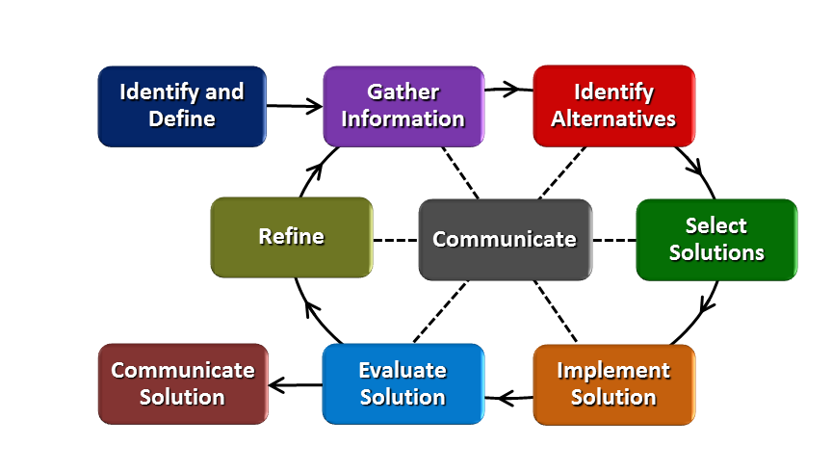
How will students test or implement the solution? What is the evidence that the solution worked?
Students will use a clay “mountain” to dig out their final design for a tunnel. They will use the graph of their functions as a template for excavation. They will test their tunnel to see if their cars will be able to traverse the tunnel safely. They will also calculate the area under the curve for optimization (smaller area is more optimal). Evidence that the solution worked will be shown by testing the model with the road and cars. The solution is successful if the cars move easily through the tunnel. The tunnel must also match the cross-sectional graph the students make before digging.
Describe how the iterative process from the EDP applies to your Challenge.
The students will first design a road and then a tunnel to match that road. They will choose functions to model the tunnel and calculate the area under the curve. This criterion will be the parameter for refinement. Students will re-design their roads and/or choose different functions in an iterative process to try to reduce the area under the curve.
How will students present or defend the solution? Describe if any formal training or resource guides will be provided to the students for best practices (e.g., poster, flyer, video, advertisement, etc.) used to present work.
Each team will do a 3-5 minute presentation describing their solution and promoting it as the best solution. They will receive a resource guide that describes some of the things they should include in the presentation. They will also have time to prepare and practice their presentations.

What academic content is being taught through this Challenge?
Algebra III includes a deep study of functions and multiple representations (graph – equation – situation). This content includes emphasis on writing equations of functions that model real-world situations.
Assessment and EDP:
Using the diagram above, identify any places in the EDP where assessments should take place, as it applies to your Challenge. Describe below what kinds of assessment are most appropriate.

What EDP Processes are ideal for conducting an Assessment? (List ones that apply.) | List the type of Assessment (Rubric, Diagram, Checklist, Model, Q/A etc.) Check box to indicate whether it is formative or summative.
_Gather Information____  _Select Solution_______  _Implement Solution___  _Evaluate Solution  _Communicate Solution______ | _Q/A___________________________ ☐ formative ☐ summative  _checklist_______________________ ☐ formative ☐ summative  _Quiz over writing equations of functions☐ formative ☐ summative  _ Verbal/written communication & justification of math used – iteration 1  ☐ formative ☐ summative  _ Verbal/written communication & justification of changes – iteration 2 ☐ formative ☐ summative  _Model of final solution (rubric)______ ☐ formative ☐ summative  _Presentation (rubric)______ ☐ formative ☐ summative
Check below which characteristic(s) of this Challenge will be incorporated in its implementation using EDP. (Check all that apply.)
☐ Has clear constraints that limit the solutions
☐ Will produce than one possible solution that works
☐ Includes the ability to refine or optimize solutions
☐ Assesses science or math content
☐ Includes Math applications
☐ Involves use of graphs
☐ Requires analysis of data
☐ Includes student led communication of findings

5. ACS (Real world applications; career connections; societal impact):
Place an X on the continuum to indicate where this Challenge belongs in the context of real world applications:
Abstract or Loosely Applies to the Real World | |--------------------------------------|----------X-----------------------------| | Strongly Applies to the Real World

Provide a brief rationale for where you placed the X:_Tunnels are an important part of infrastructure but the student models will not use complex engineering that is necessary to build an actual model. The Challenge is supposed to be an introduction to some of the ideas of engineering.___
___________________________________________________________________________________
What activities in this Unit apply to real world context? _Activtiy 1 (Hook), Activity 4 (Challenge)________

Place an X on the continuum to indicate where this Challenge belongs in the context of societal impact:
Shows Little or No Societal Impact | |----------------------------------X---|----------------------------------------| | Strongly Shows Societal Impact

Provide a brief rationale for where you placed the X: ___Good transportation systems affect quality of life. While our Challenge will not be applied directly to local society, students will see how a well-built tunnel affects people’s lives._________________________________________

What activities in this Unit apply to societal impact? ___Activity 1 (Hook)__________________________

Careers: What careers will you introduce (and how) to the students that are related to the Challenge? (Examples: career research assignment, guest speakers, fieldtrips, Skype with a professional, etc.)
Possible careers: civil engineer, geologist, structural engineer, mechanical engineer, construction management. Students will have a career research assignment and, if possible, a guest speaker.

6. Misconceptions:
- Tunnels are easy to build because they are just holes in the ground.
- There is no reason to use function equations to model a tunnel.
- Only 1 function can be used.
- The cars only need to go through the center of the tunnel.

7. Unit Lessons and Activities: (Provide a tentative timeline with a breakdown for Lessons 1 and 2. Provide the Lesson #’s and Activity #’s for when the Challenge Based Learning (CBL) and Engineering Design Process (EDP) are embedded in the unit.)
Lesson 1: Exploring Tunnels and Writing Equations
Students will examine tunnels as part of infrastructure. They will look for common characteristics such as shape, size, length, and cost, and at various professions that work on the building of tunnels. Students will begin to connect tunnels to current content on functions.
Activity 1: Introduction to Tunnels & Development of Essential Questions (2-3 days)
- Brainstorm about tunnels
- Research careers
- Watch videos about tunnels
- Big Idea, Essential Question
- Student input on Challenge (ideas about materials, how to test models) – this may continue into Activity 2
Activity 2: Writing Function Equations in Context (2 days)
- Continue content work on equations and graphs of functions/non-functions.
- Include work on modeling real world situations with equations.

Lesson 2: Connecting Tunnels to Functions
Students will work on the challenge of designing an efficient model of a tunnel.

Activity 3: Modeling Real World Situations with Functions & Non-functions (2-3 days)
- More work on modeling real world situations with equations. Students will see how combinations of functions may be used to model complicated structures.
- Guest speaker
Activity 4: Let’s Build a Tunnel (2-3 days)
- Challenge – Design a road and tunnel using function equations. Refine design and then build it and test it.
- Reflection – include thoughts on process and any further refinements needed.

Challenge Based Learning – Activity 1, Activity 4
Engineering Design Process – Activity 1, Activity 4
8. Keywords: tunnel, modeling, application of functions, optimization, civil engineering, build, design, road, transportation, infrastructure

9. Additional Resources:
- Teach Engineering https://www.teachengineering.org/activities/view/cub_rock_lesson04_activity1
- Building Big http://www.pbs.org/wgbh/buildingbig/tunnel/index.html

10. Pre-Unit and Post-Unit Assessment Instruments: Unit Pre-test - Functions

11. Poster | 12. Video (Link here.)

If you are a science teacher, check the boxes below that apply:
Next Generation Science Standards (NGSS)
Science and Engineering Practices (Check all that apply) | Crosscutting Concepts (Check all that apply)
☐ Asking questions (for science) and defining problems (for engineering) | ☐ Patterns
☐ Developing and using models | ☐ Cause and effect
☐ Planning and carrying out investigations | ☐ Scale, proportion, and quantity
☐ Analyzing and interpreting data | ☐ Systems and system models
☐ Using mathematics and computational thinking | ☐ Energy and matter: Flows, cycles, and conservation
☐ Constructing explanations (for science) and designing solutions (for engineering) | ☐ Structure and function.
☐ Engaging in argument from evidence | ☐ Stability and change.
☐ Obtaining, evaluating, and communicating information

If you are a science teacher, check the boxes below that apply:
Ohio’s Learning Standards for Science (OLS)
Expectations for Learning - Cognitive Demands (Check all that apply)
☐ Designing Technological/Engineering Solutions Using Science concepts (T)
☐ Demonstrating Science Knowledge (D)
☐ Interpreting and Communicating Science Concepts (C)
☐ Recalling Accurate Science (R)

If you are a math teacher, check the boxes below that apply:
Ohio’s Learning Standards for Math (OLS) or
Common Core State Standards -- Mathematics (CCSS)
Standards for Mathematical Practice (Check all that apply)
☐ Make sense of problems and persevere in solving them | ☐ Use appropriate tools strategically
☐ Reason abstractly and quantitatively | ☐ Attend to precision
☐ Construct viable arguments and critique the reasoning of others | ☐ Look for and make use of structure
☐ Model with mathematics | ☐ Look for and express regularity in repeated reasoning
Part 2: Post Implementation- Reflection on the Unit
Results: Evidence of Growth in Student Learning - After the Unit has been taught and the Post-Unit Assessment Instrument has been used to assess student growth in learning, the teacher must analyze the data and determine whether or not student growth in learning occurred. Present all documents used to collect and organize Post- Unit evaluation data such as graphs or charts. Provide a written analysis in sentence or paragraph form which provides the evidence that student growth in learning took place. Please present results and, if applicable, student work (as a hyperlink) used as evidence after the Unit has been taught.

Please include:
- Any documents used to collect and organize post unit evaluation data. (charts, graphs and /or tables etc.)
- An analysis of data used to measure growth in student learning providing evidence that student learning occurred. (Sentence or paragraph form.)
- Other forms of assessment that demonstrate evidence of learning.
- Anecdotal information from student feedback.

Reflection: Reflections: Reflect upon the successes of teaching in this Unit in 5 or more sentences in the form of a narrative. Consider the following questions:
- Why did you select this content for the Unit?
- Was the purpose for selecting the Unit met? If yes, provide student learning related evidence. If not, provide possible reasons.
- Did the students find a solution or solutions that resulted in concrete meaningful action for the Unit’s Challenge? Hyperlink examples of student solutions as evidence.
- What does the data indicate about growth in student learning?
- What would you change if you re-taught this Unit?
- Would you teach this Unit again? Why or why not?

Name: Kelly Lindsey | Contact Info: Kelly.lindsey@boone.kyschools.us | Date: 9 July 18

Lesson 1 : Exploring Tunnels & Writing Equations | Unit #: 1 | Lesson #: 1 | Activity #: 1
Activity 1.1.1: Introduction to Tunnels & Development of Essential Questions

Estimated Lesson Duration: | 4-5 days
Estimated Activity Duration: | 2-3 days

Setting: | classroom

Activity Objectives:
- Brainstorm what students know about tunnels
- Research possible careers related to building tunnels
- Develop the Big Idea & Essential Questions
- Student input about a Challenge

Activity Guiding Questions:
- What possible shapes are tunnels?
- What is a good tunnel?
- What do I know about tunnels?
- What did I see in the videos about tunnels?
- What is the Big Idea?
- What are some Essential Questions?
- What type of Challenge can we do?

Next Generation Science Standards (NGSS)
Science and Engineering Practices (Check all that apply) | Crosscutting Concepts (Check all that apply)
☒ Asking questions (for science) and defining problems (for engineering) | ☐ Patterns
☐ Developing and using models | ☐ Cause and effect
☒ Planning and carrying out investigations | ☐ Scale, proportion, and quantity
☐ Analyzing and interpreting data | ☐ Systems and system models
☐ Using mathematics and computational thinking | ☐ Energy and matter: Flows, cycles, and conservation
☐ Constructing explanations (for science) and designing solutions (for engineering) | ☒ Structure and function.
☐ Engaging in argument from evidence | ☐ Stability and change.
☒ Obtaining, evaluating, and communicating information

Ohio’s Learning Standards for Science (OLS)
Expectations for Learning - Cognitive Demands (Check all that apply)
☐ Designing Technological/Engineering Solutions Using Science concepts (T)
☐ Demonstrating Science Knowledge (D)
☐ Interpreting and Communicating Science Concepts (C)
☐ Recalling Accurate Science (R)

Ohio’s Learning Standards for Math (OLS) and/or
Common Core State Standards -- Mathematics (CCSS)
Standards for Mathematical Practice (Check all that apply)
☒ Make sense of problems and persevere in solving them | ☐ Use appropriate tools strategically
☐ Reason abstractly and quantitatively | ☐ Attend to precision
☒ Construct viable arguments and critique the reasoning of others | ☒ Look for and make use of structure
☐ Model with mathematics | ☐ Look for and express regularity in repeated reasoning

Unit Academic Standards (NGSS, OLS and/or CCSS):
- F-IF.8 Write a function
- F-BF.1 Build a function that models a relationship between 2 quantities
- G-MG.1 Use geometric shapes, their measures, and their properties to describe objects (e.g., modeling a tree trunk or a human torso as a cylinder.)

Materials: (Link Handouts, Power Points, Resources, Websites, Supplies)
- Brainstorm recording document – each group contributes 2-3 facts
- Career Worksheet 1.1.1a
- Template for reporting Guiding Questions

Teacher Advance Preparation:
- Upload 4-5 pre-unit videos of real tunnels to Canvas platform with reflection assignments
- Prepare pre-test over writing/using equations to model real world situations.

Activity Procedures:
- Before the unit begins, students will be assigned 4-5 short videos about various types of real tunnels. They will access them from Canvas and complete a short reflection on-line.
- On the first day of Activity 1, students will brainstorm in groups of 4 and list things they know about tunnels, using small whiteboards. Each group will share 2-3 things from their list for a class compilation of tunnel knowledge.
- Using laptops, students will research various careers related to building tunnels, hopefully including civil engineer, geologist, project management, construction, etc. They will choose one career and submit their group findings on a template. (see worksheet 1.1.1a)
- Students will identify the Big Idea.
- On day 2, students will be introduced to Challenge Based Learning and propose Essential Questions and ideas for a Challenge.
- Students will take a pre-test over writing/using equations to model real world situations.
- On day 3, students will discuss the Essential Question and devise Guiding Questions to identify what they will need to learn to complete the Challenge. Each group will submit their list of questions. At this point, students might discuss the pre-test as they write Guiding Questions.
- The Challenge will be introduced and discussed.
Formative Assessments: Link the items in the Activities that will be used as formative assessments.
Video reflections
Brainstorm lists
Career template
Pre-test
Guiding questions
Summative Assessments: These are optional; there may be summative assessments at the end of a set of Activities or only at the end of the entire Unit.

Differentiation: Describe how you modified parts of the Lesson to support the needs of different learners. Refer to Activity Template for details.

Reflection: Reflect upon the successes and shortcomings of the lesson.

Name: Kelly Lindsey | Contact Info: Kelly.lindsey@boone.kyschools.us | Date: 9 July 18

Lesson 1 : Exploring Tunnels & Writing Equations | Unit #: 1 | Lesson #: 1 | Activity #: 2
Activity 1.1.2: Writing Function Equations in Context

Estimated Lesson Duration: | 4-5 days
Estimated Activity Duration: | 2 days

Setting: | classroom

Activity Objectives:
- Analyze piece-wise functions: graph using restricted domains
- Use lines, quadratics equations to build piece-wise functions, restrict their domains, and graph
- Write equations of functions for real world problems

Activity Guiding Questions:
- How do we write equations of lines, parabolas?
- What information is needed to write these equations?
- What is a piece-wise function?
- How is a piece-wise function different from other functions?
- How do we graph a piece-wise function?
- How do we restrict the domain of a piece-wise function?
- What do we look for when writing an equation that models a real world situation?
- How do we write an equation for a real world situation?
- How does all this relate to our Big Idea and Essential Question?

Next Generation Science Standards (NGSS)
Science and Engineering Practices (Check all that apply) | Crosscutting Concepts (Check all that apply)
☐ Asking questions (for science) and defining problems (for engineering) | ☒ Patterns
☒ Developing and using models | ☐ Cause and effect
☐ Planning and carrying out investigations | ☒ Scale, proportion, and quantity
☒ Analyzing and interpreting data | ☐ Systems and system models
☒ Using mathematics and computational thinking | ☐ Energy and matter: Flows, cycles, and conservation
☐ Constructing explanations (for science) and designing solutions (for engineering) | ☒ Structure and function.
☐ Engaging in argument from evidence | ☐ Stability and change.
☒ Obtaining, evaluating, and communicating information

Ohio’s Learning Standards for Science (OLS)
Expectations for Learning - Cognitive Demands (Check all that apply)
☐ Designing Technological/Engineering Solutions Using Science concepts (T)
☐ Demonstrating Science Knowledge (D)
☐ Interpreting and Communicating Science Concepts (C)
☐ Recalling Accurate Science (R)

Ohio’s Learning Standards for Math (OLS) and/or
Common Core State Standards -- Mathematics (CCSS)
Standards for Mathematical Practice (Check all that apply)
☒ Make sense of problems and persevere in solving them | ☐ Use appropriate tools strategically
☐ Reason abstractly and quantitatively | ☒ Attend to precision
☒ Construct viable arguments and critique the reasoning of others | ☒ Look for and make use of structure
☒ Model with mathematics | ☐ Look for and express regularity in repeated reasoning

Unit Academic Standards (NGSS, OLS and/or CCSS):
- A-REI.4 Solve quadratic equations in one variable. (complete the square, extract roots, quadratic formula, factoring)
- A-REI.11 Represent & solve equations graphically. (technology, table, approximations)
- F-IF.4 For a function that models a relationship between 2 quantities, interpret key features of graphs /tables in terms of the quantities, sketch graphs
- F-IF.7 Graph functions, show key features
- F-IF.8 Write a function
- F-BF.1 Build a function that models a relationship between 2 quantities

Materials: (Link Handouts, Power Points, Resources, Websites, Supplies)
- Larson, R., College Algebra: A Graphing Approach, 5th ed.,
- Intro to Piecewise Functions Worksheet
- Piecewise Function Graphs Worksheet

Teacher Advance Preparation:
- Find a game that will review prior knowledge of linear and quadratic functions. This will be the opening for day 1.

Activity Procedures:
- Day 1 – open with a review game covering linear and quadratic equations. This might be a matching game that connects equations to graphs to situations or other characteristics. In observing the students, I will make note of any gaps in understanding that need to be addressed as we use these equations to introduce piecewise functions.
- Introduction to piecewise functions – short direct instruction that defines piecewise functions, restricted domains, and how to graph them.
- Day 2 – continue piecewise functions by doing word problems found in text book that illustrate how piecewise functions are good models for certain types of problems.
- Small Goup/Whole group discussion of how a piecewise function might model a tunnel shape. Teams will brainstorm, then share with entire class.
- Short quiz over graphing piecewise function equations.
Formative Assessments: Link the items in the Activities that will be used as formative assessments.
Game
Intro to Piecewise Functions Worksheet
Piecewise Function Graphs Worksheet
Summative Assessments: These are optional; there may be summative assessments at the end of a set of Activities or only at the end of the entire Unit.
Piecewise Function Quiz
Differentiation: Describe how you modified parts of the Lesson to support the needs of different learners.
Refer to Activity Template for details.

Reflection: Reflect upon the successes and shortcomings of the lesson.

Name: Kelly Lindsey | Contact Info: Kelly.lindsey@boone.kyschools.us | Date: 9 July 18

Lesson 2 : Connecting Tunnels to Functions | Unit #: 1 | Lesson #: 2 | Activity #: 3
Activity 1.2.3: Modeling Real World Situations with Functions & Non-Functions

Estimated Lesson Duration: | 6-7 days
Estimated Activity Duration: | 2-3 days

Setting: | classroom

Activity Objectives:
- Use semi-circles as part of piecewise functions
- Continue writing piecewise functions to model real world situations
- Discuss and understand how optimization influences the type of equations used in piecewise functions
- Find area under the curve and perimeter where needed

Activity Guiding Questions:
- How do you write the equation of a semi-circle?
- What ideas about piecewise functions do we need to review?
- What is optimization and how will we use it in our Challenge?
- How can we optimize our function models?
- What is area under the curve?
- How do we find the length of a piecewise function?

Next Generation Science Standards (NGSS)
Science and Engineering Practices (Check all that apply) | Crosscutting Concepts (Check all that apply)
☐ Asking questions (for science) and defining problems (for engineering) | ☐ Patterns
☒ Developing and using models | ☐ Cause and effect
☐ Planning and carrying out investigations | ☒ Scale, proportion, and quantity
☒ Analyzing and interpreting data | ☐ Systems and system models
☒ Using mathematics and computational thinking | ☐ Energy and matter: Flows, cycles, and conservation
☐ Constructing explanations (for science) and designing solutions (for engineering) | ☒ Structure and function.
☐ Engaging in argument from evidence | ☐ Stability and change.
☐ Obtaining, evaluating, and communicating information

Ohio’s Learning Standards for Science (OLS)
Expectations for Learning - Cognitive Demands (Check all that apply)
☐ Designing Technological/Engineering Solutions Using Science concepts (T)
☐ Demonstrating Science Knowledge (D)
☐ Interpreting and Communicating Science Concepts (C)
☐ Recalling Accurate Science (R)

Ohio’s Learning Standards for Math (OLS) and/or
Common Core State Standards -- Mathematics (CCSS)
Standards for Mathematical Practice (Check all that apply)
☒ Make sense of problems and persevere in solving them | ☐ Use appropriate tools strategically
☐ Reason abstractly and quantitatively | ☒ Attend to precision
☒ Construct viable arguments and critique the reasoning of others | ☒ Look for and make use of structure
☒ Model with mathematics | ☐ Look for and express regularity in repeated reasoning

Unit Academic Standards (NGSS, OLS and/or CCSS):
- F-IF.8 Write a function
- F-BF.1 Build a function that models a relationship between 2 quantities
- G-GPE.1 Derive the equation of a circle or given center and radius using the Pythagorean Theorem; complete the square to find the center and radius of a circle given by an equation.
- G-GPE.7 Use coordinates to compute the perimeters of polygons and areas of triangles and rectangles, e.g. using the distance formula.
- G-MG.1 Use geometric shapes, their measures, and their properties to describe objects (e.g., modeling a tree trunk or a human torso as a cylinder.)
- G-SRT.5 Use congruence and similarity criteria for triangles to solve problems and prove relationships in geometric figures.

Materials: (Link Handouts, Power Points, Resources, Websites, Supplies)
- Larson, R., College Algebra: A Graphing Approach, 5th ed.,
- Worksheet with real world situations that can be mathematically modeled by piecewise functions.
- Traveling Salesman Problem worksheet/guided notes for speaker day.

Teacher Advance Preparation:
- Find or write more problems using semi-circles in piecewise functions.
- Ask guest speaker to come and discuss optimization and how if applies to mathematical modeling.

Activity Procedures:
- Day 1 – Ask guest speaker to speak about optimization. This might include a discussion of the Traveling Salesman Problem and making decisions.
- Direct instruction - Write equations of semi-circles.
- Discover situations in which a semi-circle is a good mathematical model. Each group will have a written real world problem that can be modeled with the equation of a semi-circle. Students will work with their team to write the equation of that semi-circle. They will produce a small poster and display it on the board.
- Day 2 - Discuss results of quiz and remediate gaps in understanding. This could be done in several ways – small group discussion, peer tutoring by pairs matched by teacher or direct instruction if there is a pervasive misunderstanding.
- Introduce the equation of a circle. Discuss that it is not a function unless the domain/range are restricted.
- Day 3 – Bellringer: define & graph piecewise functions similar to those remediated yesterday. Write mathematical models for real world situations that can be defined by piecewise functions, including linear, quadratic and semi-circle functions. Each team will be given a situation to work on together. Teacher will travel to each group, asking questions and giving feedback. Students will be encouraged to find more than one function for their situation.

Formative Assessments: Link the items in the Activities that will be used as formative assessments.
Students will display small posters from Day 1 and receive feedback on their work with semi-circles.
Students will turn in mathematical models from Day 3.

Summative Assessments: These are optional; there may be summative assessments at the end of a set of Activities or only at the end of the entire Unit.

Differentiation: Describe how you modified parts of the Lesson to support the needs of different learners.
Refer to Activity Template for details.
Teacher will have extension real world situations for teams that quickly solve their first tasks.

Reflection: Reflect upon the successes and shortcomings of the lesson.

Name: Kelly Lindsey | Contact Info: Kelly.lindsey@boone.kyschools.us | Date: 9 July 18

Lesson 2 : Connecting Tunnels to Functions | Unit #: 1 | Lesson #: 2 | Activity #: 4
Activity 1.2.4: Let’s Build a Tunnel

Estimated Lesson Duration: | 6-7 days
Estimated Activity Duration: | 4 days

Setting: | classroom

Activity Objectives:
- Students will work in teams of 3-4 to design a road for the given toy cars.
- Students will write a mathematical model for a tunnel using linear, quadratic, and/or semi-circle equations based on their road.
- Students will graph their mathematical models.
- They will explain why and how they chose the equations used.
- They will find the area under the curve and the length of the curve.
- Students will refine their mathematical model, graph it, explain it, and build a physical model with clay.
- Students will test tunnels for load bearing.
- Students will present a 3-5 minute demonstration or PPT about their process and decision making for the tunnel.
- Students will reflect on the EDP and the Challenge and whether they increased students’ knowledge and understanding of piecewise functions.

Activity Guiding Questions:
- What do I need to know to design a road?
- What do I need to know to design a tunnel?
- Do I have to use a piecewise function to model my tunnel?
- What criteria do I use to develop my tunnel?
- What are the constraints for my tunnel?
- How do I graph my mathematical model?
- How can I modify and refine my model?
- What kind of test can we use to check our tunnel’s strength?
- What things does my team need to say in our presentation?
- How can we be sure that everyone speaks during the presentation?

Next Generation Science Standards (NGSS)
Science and Engineering Practices (Check all that apply) | Crosscutting Concepts (Check all that apply)
☒ Asking questions (for science) and defining problems (for engineering) | ☐ Patterns
☒ Developing and using models | ☐ Cause and effect
☐ Planning and carrying out investigations | ☒ Scale, proportion, and quantity
☐ Analyzing and interpreting data | ☐ Systems and system models
☒ Using mathematics and computational thinking | ☐ Energy and matter: Flows, cycles, and conservation
☒ Constructing explanations (for science) and designing solutions (for engineering) | ☒ Structure and function.
☐ Engaging in argument from evidence | ☐ Stability and change.
☐ Obtaining, evaluating, and communicating information

Ohio’s Learning Standards for Science (OLS)
Expectations for Learning - Cognitive Demands (Check all that apply)
☐ Designing Technological/Engineering Solutions Using Science concepts (T)
☐ Demonstrating Science Knowledge (D)
☐ Interpreting and Communicating Science Concepts (C)
☐ Recalling Accurate Science (R)

Ohio’s Learning Standards for Math (OLS) and/or
Common Core State Standards -- Mathematics (CCSS)
Standards for Mathematical Practice (Check all that apply)
☒ Make sense of problems and persevere in solving them | ☐ Use appropriate tools strategically
☐ Reason abstractly and quantitatively | ☒ Attend to precision
☒ Construct viable arguments and critique the reasoning of others | ☒ Look for and make use of structure
☒ Model with mathematics | ☐ Look for and express regularity in repeated reasoning

Unit Academic Standards (NGSS, OLS and/or CCSS):
- F-IF.8 Write a function
- F-BF.1 Build a function that models a relationship between 2 quantities
- G-GPE.1 Derive the equation of a circle or given center and radius using the Pythagorean Theorem; complete the square to find the center and radius of a circle given by an equation.
- G-GPE.7 Use coordinates to compute the perimeters of polygons and areas of triangles and rectangles, e.g. using the distance formula.
- G-MG.1 Use geometric shapes, their measures, and their properties to describe objects (e.g., modeling a tree trunk or a human torso as a cylinder.)
- G-SRT.5 Use congruence and similarity criteria for triangles to solve problems and prove relationships in geometric figures.

Materials: (Link Handouts, Power Points, Resources, Websites, Supplies)
- Larson, R., College Algebra: A Graphing Approach, 5th ed.,
- Challenge description with flow EDP chart
- Suggested outline for presentation
- Peer review sheet for students to evaluate each other’s presentations
- Clay and tools for making physical model

Teacher Advance Preparation:
- Prepare worksheets
- Prepare “mountains” out of clay
- Make sure computers are charged so teams can work on presentations.

Activity Procedures:
- Day 1: Student groups will receive instructions for the Challenge. They will discuss criteria and constraints for the tunnel. They will discuss what they will include in their models based on ideas from the various real tunnels they have watched in videos.
- They will use toy cars to design a road and then use the road to design a mathematical model for a cross-section of a tunnel. They will graph the tunnel and find the area under the curve and the length of the curve.
- Student groups will communicate with the teacher about their decisions and choices for the first model. They will document their discussion about possible revisions. Revisions may be based on the shape of their tunnel, the area under the curve, or length of the curve. Area and length might be decreased. After graphing their curve, groups may decide that a different shape would be better.
- Student groups will refine their mathematical models.
- Day 2: After choosing their best mathematical model, each team will make tunnel with clay, test it with their road and cars, and let it dry. Hopefully this will be a Friday so tunnels can dry over the weekend.
- Students will begin work on their presentation.
- Students will discuss as a class what type of testing can be done for load-bearing.
- Day 3: Students will test tunnels for load-bearing capacity.
- Students will finish presentations.
- Students will take the post-test.
- Day 4: Students will do their presentations and reflection of EDP and Challenge.
Formative Assessments: Link the items in the Activities that will be used as formative assessments.
Verbal checks on progress of models
Feedback on student work
Students will turn in diagrams of their tunnels and the graphs they produce with annotations justifying their revisions.
Summative Assessments: These are optional; there may be summative assessments at the end of a set of Activities or only at the end of the entire Unit.
Post-test
Final team report – includes final mathematical model with justifications and graphs, physical model, written outline of presentation
Presentation – including student evaluations of each team’s presentation.

Differentiation: Describe how you modified parts of the Lesson to support the needs of different learners.
Refer to Activity Template for details.

Reflection: Reflect upon the successes and shortcomings of the lesson.

